**A PROJECT STAGE – 2 *report***

***submitted* *on***

**DESIGN AND DEVELOPMENT OF AUTOMATED TYRE INFLATION SYSTEM**

**In the partial fulfillment of the requirement for the award of the degree of**

**“BACHELOR OF TECHNOLOGY”**

**IN**

**MECHANICAL ENGINEERING**

**Submitted by**

**RAMA KRISHNA MG**  **19261A0376**

**SATYA PRASAD P**  **19261A0373**

**LOHITH P**  **19261A0375**

**SHARATH CHANDRA U**  **19261A0385**

**Under the esteemed guidance**

**of**

**Mr. BV. HIMA SEKHAR SAI**

**Assistant professor**

**Department of Mechanical Engineering**



**DEPARTMENT OF MECHANICAL ENGINEERING (MECHATRONICS)**

**MAHATMA GANDHI INSTITUTE OF TECHNOLOGY**

Accredited by the National Board of Accreditation, New Delhi,

(Affiliated to Jawaharlal Nehru Technological University, Hyderabad)

Gandipet, Hyderabad – 500 075 (T.S)

[www.mgit.ac.in](http://www.mgit.ac.in/)

June 2023

**MAHATMA GANDHI INSTITUTE OF TECHNOLOGY**

Accredited by National Board of Accreditation, New Delhi,

(Affiliated to Jawaharlal Nehru Technological University, Hyderabad)

Gandipet, Hyderabad – 500 075 (T.S)

[www.mgit.ac.in](http://www.mgit.ac.in/)



**CERTIFICATE**

This is to certify that the project report entitled **DESIGN AND DEVOLOPMENT OF AUTOMATED TYRE INFLATION SYSTEM** Submitted by

**RAMA KRISHNA MG (19261A0376)**

**SATYA PRASAD P (19261A0373)**

**LOHITH P** (**19261A0375)**

**SHARATH CHANDRA U (19261A0385)**

In partial fulfillment for the award of the Degree of Bachelor of Technology in Mechanical Engineering is a record of Bonafide work carried out by him under my guidance and supervision during the academic year 2022-23. The results embodied in this project report have not been submitted to any other University or Institute for the award of any Degree or Diploma.

**Internal Guide**

**Mr. BV. Himasekhar Sai** **Dr . K. Sudhakar Reddy**

Assistant professor Head of the department

**Internal Examiner**   **External Examiner**

**ACKNOWLEDGEMENTS**

The success and outcome of this project required a lot of guidance and assistance from many people and we are extremely privileged to have got this all along with the completion of my project. All that we have done is only due to such supervision and assistance and we would not forget to thank them.

We express our sincere thanks to our guide **Mr. BV. Himasekhar Sai**, Assistant Professor his exemplary guidance, constant motivation and careful monitoring throughout the project have helped us continue with our project with ease.

We would also like to express our sincere gratitude to **Dr K. Sudhakar Reddy**, Head of the Department, Department of Mechanical Engineering (Mechatronics), for providing the opportunity and encouraging us to prepare this project.

Our sincere thanks to **Dr G. Chandra Mohan Reddy** Principal Mahatma Gandhi Institute of Technology for the encouragement and support.

Finally, we would like to express our heartfelt thanks to the entire teaching and non-teaching staff of the Department of Mechanical Engineering (Mechatronics) who have guided us throughout. Their enormous help and worthy experience have been a guiding light to us during the project

**RAMA KRISHNA MG**  **19261A0376**

**SATYA PRASAD P**  **19261A0373**

**LOHITH P**  **19261A0375**

**SHARATH CHANDRA U**  **19261A0385**

**ABSTRACT**

Roads are one of the most important modes of transport now a day’s and cars are an integral part of it. The tyre is the most essential part of an automobile and it plays a crucial role in ensuring safe driving. Tyres lose air through normal driving-especially when run through potholes and permeation. Moreover, temperature changes are also one of the reasons why tyres lose air. Thus vehicles run with an under-inflated tyre which may cause accidents. Even then, almost every automobile on the road run with either one or more underinflated tyres. A detailed survey has come with result that a drop in tire pressure by just a few PSI leads to a reduction in mileage, tire life, safe driving and vehicle performance. Unawareness of the exact pressure requirement and sudden environmental changes are some of the causes of tyres running with improper pressure. The automatic tyre pressure controlling and the inflating system ensure correct pressure in the tyre.

This project aims to develop an automatic, self-inflating tire system. Such a system ensures that tires are properly inflated at all times. The compressor will supply air to all tyres via hoses and a rotary joint fixed between the wheel spindle and wheel hub at each wheel. The Rotary joint is an integral component of the system which has half of its part rotating with the wheel and the rest of the half part is stationary. Considering today’s fast-growing environmental threats, oil price hikes and energy consumption, this system is most compatible and has potential improvement in mileage and tyre wear reduction which leads to an increase in the performance of the tyres in diverse conditions. This project aims to stabilize all automobile tires with ideal pressure, make the system automated, achieve satisfactory fuel efficiency, construct an affordable system, increase tire life and reduce accident rate by installing the system in vehicles.

**TABLE OF CONTENTS CHAPTER 1 : INTRODUCTION**

1.1 INTRODUCTION ……………...………………………………...…………...1

1.2 HOW TYRE WORKS……………………………...………………………….1-2

1.3 HOW TYRES ARE MADE…………..……………………………………….2-3

1.4 HOW TYRES SUPPORT A CAR………………….………………………...3-5

1.5 TYRE-INFLATION BASICS …………………….……………………..…5-6

**CHAPTER 2 : DESIGN** **OBJECTIVES** 7

**CHAPTER 3 : VARIOUS TIRE INFLATION SYSTEMS**

3.1 CENTRAL TYRE INFLATION SYSTEM(CTIS)……………...…………. 8-10

3.2 TYRE MAINTENANCE SYSTEM(TMS)………………………………….10-11

**CHAPTER 4 :** **ELEMENTS IN THE SYSTEM**

4.1 AIR COMPRESSOR………………………………………………………..12-13

4.1.1 RECIPROCATING COMPRESSOR………………..………………..13

4.1.2 ROATARY SCREW COMPRESSOR………………………………..13-14

4.1.3 CENTRIFUGAL COMPRESSOR……………………………………14-15

4.2 HOSE PIPE………………………………………………………………….15-16

4.3 12V RECHARGEABLE BATTERY

4.3.1 USAGE AND APPLICATIONS………………………………………16-17

4.3.2 CHARGING AND DISCHARGING………………………………….17-18

4.4 RELAY……………………………………………………………………….18

4.4.1 TYPES OF RELAYS………………………………………………..…19-24

4.5 PRESSURE SENSOR

4.5.1 WORKING………………………………………………………….…25-26

4.5.2 TYPES OF PRESSURE MEASUREMENTS…………………………26-27

4.5.2 PRESSURE SENSING TECHNOLOGY ……………………………..27-28

4.5.3 APPLICATIONS………………………………………………….…... 29-30

4.6 REGULATED POWER SUPPLY

4.6.1 INTRODUCTION…………………………………………….……..…30

4.6.2 BLOCK DIAGRAM…………………………………………….………31

4.6.3 LED…………………………………………………………………...…32-34

4.6.4 VOLATGE REGULATOR…………………………………………..…34

4.6.5 RESISTORS…………………………………………………………….35-36

4.6.6 RECTIFICATION………………………………………………………37-38

4.7 GEAR BOX…………………………………………………….….…………38-40

4.8 BEVEL GEARS……….……………………………………………………..40-42

4.9 MICROCONTROLLER……………………………………………………...42-43

4.9.1 MICROPROCESSOR VS MICROCONTROLLER…………………...43-44

4.9.2 MEMORY TYPES………………………………………………….….44-46

4.9.3 DIFFERENT DATA MEMORY TYPES………………………….…..46-47

4.9.4 PIC MICROCONTROLLERS…………………………...………….…47-49

4.9.5 CPU ARCHITECTURE…………………………………………….….49-53

4.9.6 PIN DESCRIPTION……………………………………………….…..53-57

4.9.7 APPLICATIONS ……………………………………………………...57

4.10 LCD DISPLAY

4.10.1 LCD BACKGROUND……………………..………………………….57-58

4.10.2 PIN DESCRIPTION………………….……………………………….58-60

4.10.3 CIRCUIT DESCRIPTION…………………………….………….…...60

4.10.4 APPLICATIONS ……………..……………………………………….61

**CHAPTER - 5: WORKING OF PROTOTYPE………………………………..….62-67**

**CHAPTER - 6 : SOFTWARE DESCRIPTION…………………………………....68-73**

**CHAPTER - 7 : BUDGET EXPENDITURE…………………………………..…..74-75**

**CHAPTER - 8 : ADVANTAGES………………………….……………………..…76-77**

**CHAPTER - 9 : CONCLUSION, FUTURE SCOPE AND REFERENCES…..…78-79**

**FIG NO. LIST OF FIGURES PAGE NO.**

1. PARTS OF A TIRE 2
2. INFLATED AND UNDERINFLATED TIRE 4
3. TIRE WEAR 6
4. INTERNAL PARTS OF CTIS SYSTEM 9
5. TIRE MANAGEMENT SYSTEM 11
6. RECIPROCATING AIR COMPRESSOR 13
7. CENTRIFUGAL COMPRESSOR 14
8. HOSE PIPE 16
9. SECONDARY CELL BATTERY 18
10. RELAY CIRCUIT CONFIGURATION 19
11. ELECTROMAGNETIC RELAY 19
12. SOLID STATE RELAY 22
13. SOLID STATE CONTACTORS 22
14. CIRCUIT SYMBOL OF RELAY 24
15. PIEZO RESISTIVE PRESSURE SENSOR 25
16. SILICON PIEZO RESISTIVE PRESSURE SENSOR 26
17. PARTS OF A LED 32
18. ELECTRICAL SYMBOL OF LED 33
19. VOLTAGE REGULATOR 35
20. RESISTOR 36
21. 10 RPM GEARBOX WITH DC MOTOR 38
22. BEVEL GEAR CONES 40
23. INTERNAL WORKING OF EPROM 45
24. CHAMBER OF ARRANGEMENT OF EPROM 45
25. ARCHITECTURE OF PIC MICROCONTROLLER 49
26. MEMORY UNIT IN CPU 50
27. CENTER SECTION OF MICROCONTROLLER 52
28. PINS ON PIC16F72 54
29. LCD CONFIGURATION 58
30. CIRCUIT DIAGRAM OF LCD 60
31. BLOCK DIAGRAM OF ATIS62
32. CIRCUIT FOR AUTOMATIC AIRFILLING 63
33. CIRCUIT CONFIGURATION OF ATIS 64
34. CUTTING THE MILD STEEL ROD FOR FRAME 66
35. SETTING UP THE AXLE AND PEDESTAL BEARINGS 66
36. ASSEMBLING THE COMPONENTS 67
37. TOP AND ISOMETRIC VIEW OF THE PROTOTYPE 67
38. PROGRAM ALGORITHM 68

CHAPTER – 1

**INTRODUCTION**

# **1.1 INTRODUCTION**

The mode of transport is one of the most important criterions these days. The vehicles safety is thus essential. Accidents are also increasing at a quick pace. There are several factors which causes these accidents. The improper inflation of tyres is one among them. Tyres lose air through normal driving (especially after hitting pot holes or curbs), permeation and seasonal changes in temperature. When tyres are under inflated, the tread wears more quickly. Under inflated tyres get damaged quickly due to overheating ascompared to properly inflated tyres. The under inflation also causes a small depreciation in the mileage as well. Above all the vehicles running with under inflated tyres can cause accidents.

Thus to rectify all these defects we are using self inflating systems. The pressure monitoring systems in such systems helps in monitoring the tyre pressure constantly. The system which contains sensors feed the information to a display panel which the driver can operate manually. The electronic unit controls all the information. The source of air is taken from the vehicles air braking system or from the pneumatic systems. Thus it helps in re-inflation of the tyres to proper pressure conditions.

# **1.2 How Tyres Work**

If you're in the market for new tyres, all of the variables in tyre specifications and the confusing jargon you might hear from tyre salesmen or "experts" might make your purchase rather stressful. Or maybe you just want to fully understand the tyres you already have, the concepts at work, the significance of all of those sidewall markings. What does all this stuff mean in regular terms?

In this article, we will explore how tyres are built and see what's in a tyre. We'll find out what all the numbers and markings on the sidewall of a tyre mean, and we'll decipher some of that tyre jargon. By the end of this article, you'll understand how a tyre supports your car, and you'll know why heat can build up in your tyres, especially if the pressure is low. You'll also be able to adjust your tyre pressure correctly and diagnose some common tyre problems!

**1.3 How Tyres are Made ?**

As illustrated below, a tyre is made up of several different components.

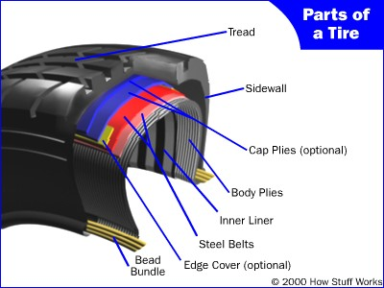

**Fig 1 – Parts of a Tire**

**The Bead Bundle:** The bead is a loop of high-strength steel cable coated with rubber. It gives the tyre the strength it needs to stay seated on the wheel rim and to handle the forces applied by tyre mounting machines when the tyres are installed on rims.

**The Body:** The body is made up of several layers of different fabrics, called plies. The most common ply fabric is polyester cord. The cords in a radial tyre run perpendicular to the tread. Some older tyres used diagonal bias tyres, tyres in which the fabric ran at an angle to the tread. The plies are coated with rubber to help them bond with the other components and to seal in the air. A tyre's strength is often described by the number of plies it has. Most car tyres have two body plies. By comparison, large commercial jetliners often have tyres with 30 or more plies.

**The Belts:** In steel-belted radial tyres, belts made from steel are used to reinforce the area under the tread. These belts provide puncture resistance and help the tyre stay flat so that it makes the best contact with the road.

**Cap Plies:** Some tyres have cap plies, an extra layer or two of polyester fabric to help hold everything in place. These cap plies are not found on all tyres; they are mostly used on tyres with higher speed ratings to help all the components stay in place at high speeds.

**The Sidewall:** The sidewall provides lateral stability for the tyre, protects the body plies and helps keep the air from escaping. It may contain additional components to help increase the lateral stability.

**The Tread:** The tread is made from a mixture of many different kinds of natural and synthetic rubbers. The tread and the sidewalls are extruded and cut to length. The tread is just smooth rubber at this point; it does not have the tread patterns that give the tyre traction.

**Assembly :** All of these components are assembled in the tyre-building machine. This machine ensures that all of the components are in the correct location and then forms the tyre into a shape and size fairly close to its finished dimensions.

# 1.4 How Tyres Support a Car

You may have wondered how a car tyre with 30 pounds per square inch ( psi ) of pressure can support a car. This is an interesting question, and it is related to several other issues, such as how much force it takes to push a tyre down the road and why tyres get hot when you drive (and how this can lead to problems).

The next time you get in your car, take a close look at the tyres. You will notice that they are not really round. There is a flat spot on the bottom where the tyre meets the road. This flat spot is called the contact patch.

If you were looking up at a car through a glass road, you could measure the size of the contact patch. You could also make a pretty good estimate of the weight of your car, if you measured the area of the contact patches of each tyre, added them together and then multiplied the sum by the tyre pressure. Since there is a certain amount of pressure per square inch in the tyre, say 30 psi, then you need quite a few square inches of contact patch to carry the weight of the car. If you add more weight or decrease the pressure, then you need even more square inches of contact patch, so the flat spot gets bigger.

|  |
| --- |
| **Fig 2 - A properly inflated tyre and an under inflated or overloaded tyre** |

You can see that the under inflated/overloaded tyre is less round than the properly inflated, properly loaded tyre. When the tyre is spinning, the contact patch must move around the tyre to stay in contact with the road. At the spot where the tyre meets the road, the rubber is bent out. It takes force to bend that tyre, and the more it has to bend, the more force it takes. The tyre is not perfectly elastic, so when it returns to its original shape, it does not return all of the force that it took to bend it. Some of that force is converted to heat in the tyre by the friction and work of bending all of the rubber and steel in the tyre. Since an under inflated or overloaded tyre needs to bend more, it takes more force to push it down the road, so it generates more heat.

Tyre manufacturers sometimes publish a coefficient of rolling friction (CRF) for their tyres. You can use this number to calculate how much force it takes to push a tyre down the road. The CRF has nothing to do with how much traction the tyre has; it is used to calculate the amount of drag or rolling resistance caused by the tyres. The CRF is just like any other coefficient of rolling friction: The force required to overcome the friction is equal to the CRF multiplied by the weight on the tyre. This table lists typical CRF for several different types of wheels.

|  |  |
| --- | --- |
| Tyre Type | Coefficient of Rolling Friction |
| Low rolling resistance car tyre | 0.006 - 0.01 |
| Ordinary car tyre | 0.015 |
| Truck tyre | 0.006 - 0.01 |
| Train wheel | 0.001 |

Let's figure out how much force a typical car might use to push its tyres down the road. Let's say our car weighs 4,000 pounds (1814.369 kg), and the tyres have a CRF of 0.015. The force is equal to 4,000 x 0.015, which equals 60 pounds (27.215 kg). Now let's figure out how much power that is. We know that power is equal to force times speed. So the amount of power used by the tyres depends on how fast the car is going. At 75 mph (120.7 kph), the tyres are using 12hp, and at 55 mph (88.513 kph) they use 8.8 horsepower. All of that power is turning into heat. Most of it goes into the tyres, but some of it goes into the road (the road actually bends a little when the car drives over it).

From these calculations you can see that the three things that affect how much force it takes to push the tyre down the road (and therefore how much heat builds up in the tyres) are the weight on the tyres, the speed you drive and the CRF (which increases if pressure is decreased). If you drive on softer surfaces, such as sand, more of the heat goes into the ground, and less goes into the tyres, but the CRF goes way up.

# 1.5. Tyre-inflation Basics

About 80 percent of the cars on the road are driving with one or more tyres underinflated. Tyres lose air through normal driving (especially after hitting pot holes or curbs), permeation and seasonal changes in temperature. They can lose one or two psi (pounds per square inch) each month in the winter and even more in the summer. And, you can't tell if they're properly inflated just by looking at them. You have to use a tyre-pressure guage. Not only is underinflation bad for your tyres, but it's also bad for your gas mileage, affects the way your car handles and is generally unsafe.

**Problems with Tyres**

When tyres are under-inflated, the tread wears more quickly. According to Goodyear, this equates to 15 percent fewer miles you can drive on them for every 20 percent that they're underinflated. Underinflated tyres also overheat more quickly than properly inflated tyres, which cause more tyre damage. The faded areas below indicate areas of excessive tread wear.

|  |
| --- |
|  |

**Fig 3 – Tire wear based on air amount inflated**

Because tyres are flexible, they flatten at the bottom when they roll. This contact patch rebounds to its original shape once it is no longer in contact with the ground. This rebound creates a wave of motion along with some friction. When there is less air in the tyre, that wave is larger and the friction created is greater and friction creates heat. If enough heat is generated, the rubber that holds the tyre's cords together begin to melt and the tyre fails. Because of the extra resistance an underinflated tyre has when it rolls, your car's engine has to work harder. A statistics show that tyres that are underinflated by as little as 2 psi reduce fuel efficiency by 10 percent. Over a year of driving, that can amount to several hundred dollars in extra gas purchases.

**CHAPTER - 2**

**DESIGN OBJECTIVES:**

Tyre-inflation systems have three general goals:

* To detect when the air pressure in a particular tyre has dropped - This means they have to constantly (or intermittently) monitor the air pressure in each tyre.
* To notify the cpu of the problem
* To inflate that tyre back to the proper level - This means there has to be an air supply as well as a check valve that opens only when needed.

**Parts of Any Self-inflating System**

While the available tyre inflation systems vary in design, they share some common elements.

* They all use some type of valve to isolate individual tyres to prevent airflow from all tyres when one is being checked or inflated.
* They have a method for sensing the tyre pressures. This is addressed in most cases with central sensors that relay information to an electronic control unit and then to the driver.
* They have an air source, which is usually an existing onboard source such as braking or pneumatic systems. When using an existing system, however, they have to ensure that they don't jeopardize its original function. For this reason, there are safety checks to ensure that there is enough air pressure for the source's primary use before pulling air for tyre inflation.
* There has to be a pressure relief vent to vent air from the tyre without risking damage to the hub.
* There has to be a way to get the air from the air source to the tyres, which is usually through the axle. Systems either use a sealed-hub axle with a hose from the hub to the tyre valve or else they run tubes through the axle with the axle acting as a conduit or rear-axle seals.

**CHAPTER - 3**

# vARIOUS TIRE INFLATION SYSTems

# 3.1 Central Tyre Inflation System (CTIS)

The idea behind the CTIS is to provide control over the air pressure in each tyre as a way to improve performance on different surfaces. For example, lowering the air pressure in a tyre creates a larger area of contact between the tyre and the ground and makes driving on softer ground much easier. It also does less damage to the surface. This is important on work sites and in agricultural fields. By giving the driver direct control over the air pressure in each tyre, maneuverability is greatly improved.

Another function of the CTIS is to maintain pressure in the tyres if there is a slow leak or puncture. In this case, the system controls inflation automatically based on the selected pressure the driver has set.

There are two main manufacturers of the CTIS: U.S.-based Dana Corporation and France-based Syegon (a division of GIAT). Dana Corporation has two versions, the CTIS for military use (developed by PSI) and the Tyre Pressure Control System (TPCS) for commercial, heavy machinery use. In the next section, we'll take a look at the inner workings of a basic CTIS setup.

**CTIS: Inside**

Here is a look at the overall system:

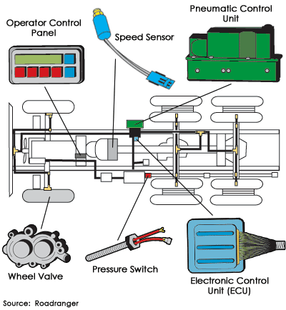

**Fig 4 – Internal parts of CTIS system**

A wheel valve is located at each wheel end. For dual wheels, the valves are typically connected only to the outer wheel so the pressure between the two tyres can be balanced. Part of the wheel valve's job is to isolate the tyre from the system when it's not in use in order to let the pressure off of the seal and extend its life. The wheel valve also enables on-demand inflation and deflation of the tyres.

An electronic control unit (ECU) mounted behind the passenger seat is the brain of the system. It processes driver commands, monitors all signals throughout the system and tells the system to check tire pressures every 10 minutes to make sure the selected pressure is being maintained.

The ECU sends commands to the pneumatic control unit, which directly controls the wheel valves and air system. The pneumatic control unit also contains a sensor that transmits tyre-pressuretire-pressurethe ECU.

An operator control panel allows the driver to select tyre-pressure modes to match current conditions. This dash-mounted panel displays current tyre pressures, selected modes and system status. When the driver selects a tyre-pressure setting, signals from the control panel travel to the electronic control unit to the pneumatic control unit to the wheel valves. When vehicles are moving faster (like on a highway), tyre pressure should be higher to prevent tyre damage. The CTIS includes a speed sensor that sends vehicle speed information to the electronic control unit. If the vehicle continues moving at a higher speed for a set period of time, the system automatically inflates the tyres to an appropriate pressure for that speed.

This type of system uses air from the same compressor that supplies air to the brakes. A pressure switch makes sure the brake system gets priority, preventing the CTIS from taking air from the supply tank until the brake system is fully charged.

**3.2 Tyre Maintenance System (TMS)**

# Dana Corporation's Tyre Maintenance System is a "smart" system for tractor trailers that monitors tyre pressure and inflates tyres as necessary to keep pressure at the right level. It uses air from the trailer's brake supply tank to inflate the tyres.

The system has three main components:

* The tyre hose assembly provides the air route to inflate the tyre and has check valves so that the air lines and seals do not have to be pressurized when the system is not checking or inflating the tyres. This cuts down on wear and tear on the seals.
* The rotary joint is comprised of air and oil seals and bearings and connects the air hose from the non-rotating axle to the rotating hubcap. Its air seals prevent leakage, and the oil seal prevents contamination. The rotary hub also has a vent to release air pressure in the hubcap.
* The manifold houses the pressure protection valve, which makes sure the system doesn't pull air if the brakes' air supply is below 80 psi. It also houses an inlet filter to keep the air clean, a pressure sensor to measure tyre pressures and solenoids that control airflow to the tyres.

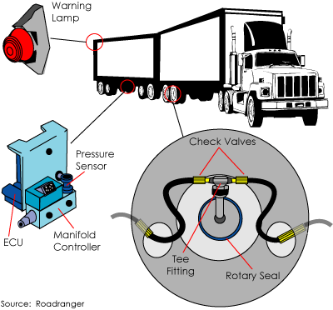

**Fig 5 – Arrangaments of components in Tire management system**

Like the CTIS, this system also has an electronic control unit that runs the entyre system. It performs checks to make sure the system is operational, notifies the driver via a warning light on the trailer (visible through the rear-view mirror) if a tyre's pressure drops more than 10 percent below its normal pressure and performs system diagnostics.

The system performs an initial pressure check and adds air to any tyre that needs it. The check valves in each tyre hose ensure that the other tyres don't lose pressure while one tyre is being inflated. After an initial pressure check, the system depressurizes to relieve pressure from the seals. Every 10 minutes, the system pressurizes the lines and rechecks tyre pressures.

**CHAPTER - 4**

**ELEMENTS IN THE SYSTEM**

**4.1 Air Compressor**

An **air compressor** is a device that converts power (usually from an electric motor, a diesel engine or a gasoline engine) into kinetic energy by compressing and pressurizing air, which, on command, can be released in quick bursts. There are numerous methods of air compression, divided into either positive-displacement or negative-displacement. Positive-displacement air compressors work by forcing air into a chamber whose volume is reduced to compress the air. Piston-type air compressors use this principle by pumping air into an air chamber through the use of the constant motion of pistons. They use one-way valves to guide air into a chamber, where the air is compressed. Rotary screw compressors also use positive-displacement compression by matching two helical screws that, when turned, guide air into a chamber, whose volume is reduced as the screws turn. Vane compressors use a slotted rotor with varied blade placement to guide air into a chamber and compress the volume.

Negative-displacement air compressors include centrifugal compressors. These use centrifugal force generated by a spinning impeller to accelerate and then decelerate captured air, which pressurizes it.

## Conventional air compressors are used in several applications

* To supply high-pressure clean air to fill gas cylinders
* To supply moderate-pressure clean air to a submerged surface supplied diver
* To supply moderate-pressure clean air for driving some office and school building pneumatic HVAC control system valves
* To supply a large amount of moderate-pressure air to power pneumatic tools
* For filling tires
* To produce large volumes of moderate-pressure air for large-scale industrial processes (such as oxidation for petroleum coking or cement plant bag house purge systems).

Most air compressors either are reciprocating piston type, rotary vane or rotary screw. Centrifugal compressors are common in very large applications. There are two main types of air compressor's pumps: oil-lubed and oil-less. The oil-less system has more technical development, but is more expensive, louder and lasts for less time than oil-lubed pumps. The oil-less system also delivers air of better quality.

**4.1.1Reciprocating compressor**

A reciprocating compressor or piston compressor is a positive-displacement compressor that uses pistons driven by a crankshaft to deliver gases at high pressure.

The intake gas enters the suction manifold, then flows into the compression cylinder where it gets compressed by a piston driven in a reciprocating motion via a crankshaft, and is then discharged. Applications include oil refineries, gas pipelines, chemical plants, natural gas processing plants and refrigeration plants. One specialty application is the blowing of plastic bottles made of polyethylene terephthalate.

**4.1.2Rotary screw compressor**

A rotary screw compressor is a type of gas compressor which uses a rotary type positive displacement mechanism. They are commonly used to replace piston compressors where large volumes of high pressure air are needed, either for large industrial applications or to operate high-power air tools such as jackhammers.

The gas compression process of a rotary screw is a continuous sweeping motion, so there is very little pulsation or surging of flow, as occurs with piston compressors.

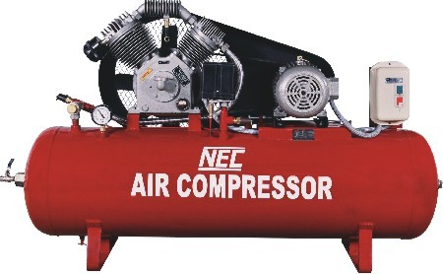

**Fig 6 – Reciprocating air compressor**

Reciprocating Compressors are one of the most widely used [types of compressors](http://www.brighthubengineering.com/hvac/51688-principle-of-working-of-refrigeration-reciprocating-compressors/www.brighthubengineering.com/hvac/33373-introduction-to-compressors/) for refrigeration and air conditioning applications. The reciprocating compressors comprise of the piston and the cylinder arrangement similar to the automotive engine. While the engine generates power after consuming fuel, the reciprocating compressor consumes electricity to compress the refrigerant. Inside the cylinder the piston performs reciprocating motion which enables the compression of refrigerant inside it.

Positive-displacement air compressors work by forcing air into a chamber whose volume is reduced to compress the air. Piston-type air compressors use this principle by pumping air into an air chamber through the use of the constant motion of pistons. They use unidirectional valves to guide air into a chamber, where the air is compressed. Rotary screw compressors also use positive-displacement compression by matching two helical screws that, when turned, guide air into a chamber, the volume of which is reduced as the screws turn. Vane compressors use a slotted rotor with varied blade placement to guide air into a chamber and compress the volume.

Negative-displacement air compressors include centrifugal compressors. These devices use centrifugal force generated by a spinning impeller to accelerate and then decelerate captured air, which pressurizes it.

**4.1.3 Centrifugal Compressor**:

Centrifugal compressor consists of a rotating impeller soruonded by a diffuser as shown in fig the impeller and diffuser are concentric and are enclosed in a volute casing. The clearance between casing and diffuser gradually increases towards the delivery side.

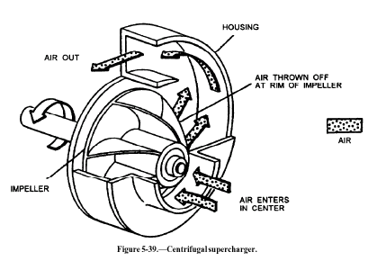

**Fig 7 – Centrifugal Compressor**

The air enters through the eye of an impeller. Due to centrifugal force air flows radially outwards with high velocity. As the air moving outwards, more air flows into the impeller, creating a continuous air flow. The air high velocity passes into a diffuser where the kinetic energy acquired is converted into pressure energy.

The air at high pressure is delivered to the receiver through the divergent passage of casing. This type compressor is a continuous flow device, and deals with large quantities 0of air at moderate pressures. The pressure ratios between 4:1 to 6:1 may be achieved. Centrifugal compressors are used as super charger for I.C engines and compressor for gas turbine unit.

Conventional air compressors are used in several different applications:

* To supply high-pressure clean air to fill gas cylinders
* To supply moderate-pressure clean air to a submerged surface supplied diver
* To supply moderate-pressure clean air for driving some office and school building pneumatic HVAC control system valves
* To supply a large amount of moderate-pressure air to power pneumatic tools
* For filling tires
* To produce large volumes of moderate-pressure air for macroscopic industrial processes (such as oxidation for petroleum coking or cement plant bag house purge systems).

Most air compressors are reciprocating piston type, rotary vane or rotary screw. Centrifugal compressors are common in very large applications. There are two main types of air compressor's pumps: Oil lubed and oil-less. The oil-less system has more technical development, but they are more expensive, louder and last for less time than the oiled lube pumps. However, the air delivered has better quality.

**4.2 Hose pipe**

A flexible pipe used to carry the liquid or gas. a hose that carries air under pressure. Our range of industrial hose pipe used top conveys the high pressure compressed air from storage tank to engine cylinder. The hose is used in our project is international standard of quality and safety. Available in different specifications, these hose pipes can be availed from us at market leading prices.

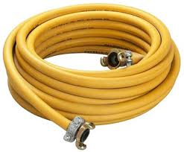

**Fig 8– Hose pipe**

**4.3 12V Rechargeable Batter**

**A** rechargeable battery, storage battery, or accumulator is a type of [electrical battery](http://en.wikipedia.org/wiki/Electrical_battery). It comprises one or more [electrochemical cells](http://en.wikipedia.org/wiki/Electrochemical_cell), and is a type of [energy accumulator](http://en.wikipedia.org/wiki/Accumulator_(energy)). It is known as a secondary cell because its [electrochemical](http://en.wikipedia.org/wiki/Electrochemistry) [reactions](http://en.wikipedia.org/wiki/Chemical_reaction) are electrically reversible. Rechargeable batteries come in many different shapes and sizes, ranging from [button cells](http://en.wikipedia.org/wiki/Button_cell#Rechargeable_variants) to megawatt systems connected to [stabilize](http://en.wikipedia.org/wiki/Grid_energy_storage) an electrical distribution network. Several different com binations of chemicals are commonly used, including: [lead–acid](http://en.wikipedia.org/wiki/Lead%E2%80%93acid_battery),[nickel cadmium](http://en.wikipedia.org/wiki/Nickel%E2%80%93cadmium_battery) (NiCd), [nickel metal hydride](http://en.wikipedia.org/wiki/Nickel%E2%80%93metal_hydride_battery) (NiMH), [lithium ion](http://en.wikipedia.org/wiki/Lithium_ion_battery) (Li-ion), and [lithium ion polymer](http://en.wikipedia.org/wiki/Lithium_ion_polymer_battery) (Li-ion polymer).

Rechargeable batteries have lower total cost of use and environmental impact than disposable batteries. Some rechargeable battery types are available in the same [sizes](http://en.wikipedia.org/wiki/List_of_battery_sizes) as disposable types. Rechargeable batteries have higher initial cost but can be recharged very cheaply and used many times.

## **4.3.1 Usage and applications**

Rechargeable batteries are used for [automobile starters](http://en.wikipedia.org/wiki/Car_battery), portable consumer devices, light vehicles (such as [motorized wheelchairs](http://en.wikipedia.org/wiki/Wheelchair#Electric-powered_wheelchairs), [golf carts](http://en.wikipedia.org/wiki/Golf_carts), [electric bicycles](http://en.wikipedia.org/wiki/Electric_bicycles), and electric [forklifts](http://en.wikipedia.org/wiki/Forklifts)), tools, and [uninterruptible power supplies](http://en.wikipedia.org/wiki/Uninterruptible_power_supply). Emerging applications in [hybrid electric vehicles](http://en.wikipedia.org/wiki/Hybrid_electric_vehicle) and [electric vehicles](http://en.wikipedia.org/wiki/Battery_electric_vehicle) are driving the technology to reduce cost and weight and increase lifetime.

Traditional rechargeable batteries have to be charged before their first use; newer [low self-discharge NiMH batteries](http://en.wikipedia.org/wiki/Low_self-discharge_NiMH_battery) hold their charge for many months, and are typically charged at the factory to about 70% of their rated capacity before shipping.

[Grid energy storage](http://en.wikipedia.org/wiki/Grid_energy_storage) applications use rechargeable batteries for load leveling, where they store electric energy for use during peak load periods, and for [renewable energy](http://en.wikipedia.org/wiki/Renewable_energy) uses, such as storing power generated from [photovoltaic arrays](http://en.wikipedia.org/wiki/Photovoltaic_array) during the day to be used at night. By charging batteries during periods of low demand and returning energy to the grid during periods of high electrical demand, load-leveling helps eliminate the need for expensive [peaking power plants](http://en.wikipedia.org/wiki/Peaking_power_plant) and helps [amortize](http://en.wikipedia.org/wiki/Amortization_(business)" \o "Amortization (business))the cost of generators over more hours of operation.

The US [National Electrical Manufacturers Association](http://en.wikipedia.org/wiki/National_Electrical_Manufacturers_Association) has estimated that U.S. demands for rechargeable batteries is growing twice as fast as demand for non rechargeable.

**4.3.2Charging and discharging**

Further information: [Battery charger](http://en.wikipedia.org/wiki/Battery_charger)

During charging, the positive active material is [oxidized](http://en.wikipedia.org/wiki/Oxidized), producing [electrons](http://en.wikipedia.org/wiki/Electron), and the negative material is [reduced](http://en.wikipedia.org/wiki/Redox), consuming electrons. These electrons constitute the [current](http://en.wikipedia.org/wiki/Electric_current) flow in the external [circuit](http://en.wikipedia.org/wiki/Electrical_network). The [electrolyte](http://en.wikipedia.org/wiki/Electrolyte) may serve as a simple buffer for internal ion flow between the [electrodes](http://en.wikipedia.org/wiki/Electrode), as in [lithium-ion](http://en.wikipedia.org/wiki/Lithium-ion_battery) and [nickel-cadmium](http://en.wikipedia.org/wiki/Nickel-cadmium_battery) cells, or it may be an active participant in the [electrochemical](http://en.wikipedia.org/wiki/Electrochemical) reaction, as in [lead–acid](http://en.wikipedia.org/wiki/Lead%E2%80%93acid_battery) cells.

[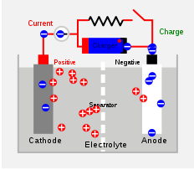](http://en.wikipedia.org/wiki/File:Secondary_Cell_Diagram.svg)

**Fig 9 - Diagram of the charging of a secondary cell battery.**

The energy used to charge rechargeable batteries usually comes from a [battery charger](http://en.wikipedia.org/wiki/Battery_charger)using AC [mains electricity](http://en.wikipedia.org/wiki/Mains_electricity), although some are equipped to use a vehicle's 12-volt DC power outlet. Regardless, to store energy in a secondary cell, it has to be connected to a DC voltage source. The negative terminal of the cell has to be connected to the negative terminal of the voltage source and the positive terminal of the voltage source with the positive terminal of the battery. Further, the voltage output of the source must be higher than that of the battery, but not much higher: the greater the difference between the power source and the battery's voltage capacity, the faster the charging process, but also the greater the risk of overcharging and damaging the battery.

Chargers take from a few minutes to several hours to charge a battery. Slow "dumb" chargers without voltage- or temperature-sensing capabilities will charge at a low rate, typically taking 14 hours or more to reach a full charge. Rapid chargers can typically charge cells in two to five hours, depending on the model, with the fastest taking as little as fifteen minutes.

**4.4 Relay:**

A **relay** is an electrically operated switch. Many relays use an electromagnet to operate a switching mechanism, but other operating principles are also used. Relays find applications where it is necessary to control a circuit by a low-power signal, or where several circuits must be controlled by one signal. The first relays were used in long distance telegraph circuits, repeating the signal coming in from one circuit and re-transmitting it to another. Relays found extensive use in telephone exchanges and early computers to perform logical operations. A type of relay that can handle the high power required to directly drive an electric motor is called a contactor. Solid-state relays control power circuits with no moving parts, instead using a semiconductor device triggered by light to perform switching. Relays with calibrated operating characteristics and sometimes multiple operating coils are used to protect electrical circuits from overload or faults; in modern electric power systems these functions are performed by digital instruments still called "protection relays".

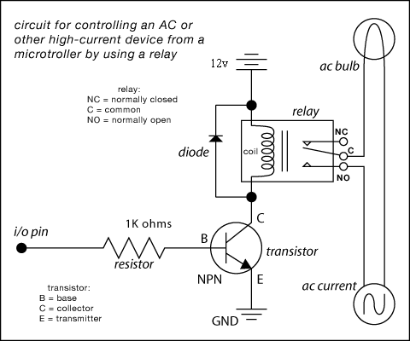

**Fig 10 – Relay circuit configuration**

## **4.4.1 Types of relays:**

1. Simple electromechanical relay:

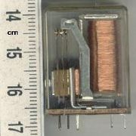

**Fig 11- Electro magnetic relay**

A simple electromagnetic relay, such as the one taken from a car in the first picture, is an adaptation of an electromagnet. It consists of a coil of wire surrounding a soft iron core, an iron yoke, which provides a low reluctance path for magnetic flux, a movable iron [armature](http://en.wikipedia.org/wiki/Armature_%28electrical_engineering%29), and a set, or sets, of contacts; two in the relay pictured. The armature is hinged to the yoke and mechanically linked to a moving contact or contacts. It is held in place by a spring so that when the relay is de-energized there is an air gap in the magnetic circuit.

**Basic design and operation:**

When an electric current is passed through the coil, the resulting magnetic field attracts the armature and the consequent movement of the movable contact or contacts either makes or breaks a connection with a fixed contact. If the set of contacts was closed when the relay was De-energized, then the movement opens the contacts and breaks the connection, and vice versa if the force, approximately half as strong as the magnetic force, to its relaxed position. Usually this force is provided by a spring, but gravity is also used commonly in industrial motor starters. Most relays are manufactured to operate quickly. In a low voltage application, this is to reduce noise. In a high voltage or high current application, this is to reduce arcing.

If the coil is energized with DC, a diode is frequently installed across the coil, to dissipate the energy from the collapsing magnetic field at deactivation, which would otherwise generate a voltage spike dangerous to circuit components. Some automotive relays already include a diode inside the relay case. Alternatively a contact protection network, consisting of a capacitor and resistor in series, may absorb the surge. If the coil is designed to be energized with AC, a small copper ring can be crimped to the end of the solenoid. This "shading ring" creates a small out-of-phase current, which increases the minimum pull on the armature during the AC cycle.

By analogy with the functions of the original electromagnetic device, a solid-state relay is made with a thyristor or other solid-state switching device. To achieve electrical isolation an opt coupler can be used which is a light-emitting diode (LED) coupled with a photo transistor. Small relay as used in electronics

### 2. Latching relay

Latching relay, dust cover removed, showing pawl and ratchet mechanism. The ratchet operates a cam, which raises and lowers the moving contact arm, seen edge-on just below it. The moving and fixed contacts are visible at the left side of the image.

3. Reed relay

A reed relay has a set of contacts inside a vacuum or inert gas filled glass tube, which protects the contacts against atmospheric corrosion. The contacts are closed by a magnetic field generated when current passes through a coil around the glass tube. Reed relays are capable of faster switching speeds than larger types of relays, but have low switch current and voltage ratings

4. Mercury-wetted relay

A mercury-wetted reed relay is a form of reed relay in which the contacts are wetted with mercury. Such relays are used to switch low-voltage signals (one volt or less) because of their low contact resistance, or for high-speed counting and timing applications where the mercury eliminates contact bounce. Mercury wetted relays are position-sensitive and must be mounted vertically to work properly. Because of the toxicity and expense of liquid mercury, these relays are rarely specified for new equipment. See also mercury switch.

### 5. Polarized relay

### A polarized relay placed the armature between the poles of a permanent magnet to increase sensitivity. Polarized relays were used in middle 20th Century telephone exchanges to detect faint pulses and correct telegraphic distortion. The poles were on screws, so a technician could first adjust them for maximum sensitivity and then apply a bias spring to set the critical current that would operate the relay.

### 6.Machine tool relay

### A machine tool relay is a type standardized for industrial control of machine tools, transfer machines, and other sequential control. They are characterized by a large number of contacts (sometimes extendable in the field) which are easily converted from normally-open to normally-closed status, easily replaceable coils, and a form factor that allows compactly installing many relays in a control panel. Although such relays once were the backbone of automation in such industries as automobile assembly, the programmable logic controller (PLC) mostly displaced the machine tool relay from sequential control applications.

7. Contactor relay

A contactor is a very heavy-duty relay used for switching electric motors and lighting loads. Continuous current ratings for common contactors range from 10 amps to several hundred amps. High-current contacts are made with alloys containing silver. The unavoidable arcing causes the contacts to oxidize; however, silver oxide is still a good conductor.

### 8. Solid-state relay

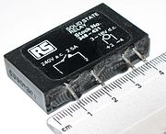

**Fig 12 - Solid state relay, which has no moving parts**

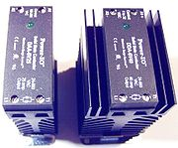

**Fig 13 - 25 A or 40 A solid state contactors**

A solid state relay (SSR) is a solid state electronic component that provides a similar function to an electromechanical relay but does not have any moving components, increasing long-term reliability. With early SSR's, the tradeoff came from the fact that every transistor has a small voltage drop across it. This voltage drop limited the amount of current a given SSR could handle. As transistors improved, higher current SSR's, able to handle 100 to 1,200 Amperes, have become commercially available. Compared to electromagnetic relays, they may be falsely triggered by transients.

9. Solid state contactor relay

A solid state contactor is a very heavy-duty solid state relay, including the necessary heat sink, used for switching electric heaters, small electric motors and lighting loads; where frequent on/off cycles are required. There are no moving parts to wear out and there is no contact bounce due to vibration. They are activated by AC control signals or DC control signals from Programmable logic controller (PLCs), PCs, Transistor-transistor logic (TTL) sources, or other microprocessor and microcontroller controls.

10. Buchholz relay

A Buchholz relay is a safety device sensing the accumulation of gas in large oil-filled transformers, which will alarm on slow accumulation of gas or shut down the transformer if gas is produced rapidly in the transformer oil.

11. Forced-guided contacts relay

A forced-guided contacts relay has relay contacts that are mechanically linked together, so that when the relay coil is energized or de-energized, all of the linked contacts move together. If one set of contacts in the relay becomes immobilized, no other contact of the same relay will be able to move. The function of forced-guided contacts is to enable the safety circuit to check the status of the relay. Forced-guided contacts are also known as "positive-guided contacts", "captive contacts", "locked contacts", or "safety relays".

12. Overload protection relay

Electric motors need over current protection to prevent damage from over-loading the motor, or to protect against short circuits in connecting cables or internal faults in the motor windings. One type of electric motor overload protection relay is operated by a heating element in series with the electric motor. The heat generated by the motor current heats a bimetallic strip or melts solder, releasing a spring to operate contacts. Where the overload relay is exposed to the same environment as the motor, a useful though crude compensation for motor ambient temperature is provided.

## 13. Pole and throw:

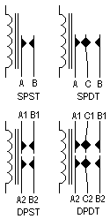

**Fig 14 -Circuit symbols of relays.**

"C" denotes the common terminal in SPDT and DPDT types.

Since relays are switches, the terminology applied to switches is also applied to relays. A relay will switch one or more poles, each of whose contacts can be thrown by energizing the coil in one of three ways:

* Normally-open (**NO**) contacts connect the circuit when the relay is activated; the circuit is disconnected when the relay is inactive. It is also called a **Form A** contact or "make" contact.
* Normally-closed (**NC**) contacts disconnect the circuit when the relay is activated; the circuit is connected when the relay is inactive. It is also called a **Form B** contact or "break" contact.
* Change-over (**CO**), or double-throw (**DT**), contacts control two circuits: one normally-open contact and one normally-closed contact with a common terminal. It is also called a **Form C** contact or "transfer" contact ("break before make"). If this type of contact utilizes” make before break" functionality, then it is called a **Form D** contact.

**4.5 Pressure sensor**

A pressure sensor measures [pressure](http://en.wikipedia.org/wiki/Pressure), typically of [gases](http://en.wikipedia.org/wiki/Gas) or [liquids](http://en.wikipedia.org/wiki/Liquids). Pressure is an expression of the force required to stop a fluid from expanding, and is usually stated in terms of force per unit area. A pressure sensor usually acts as a [transducer](http://en.wikipedia.org/wiki/Transducer); it generates a signal as a [function](http://en.wikipedia.org/wiki/Function_%28mathematics%29) of the pressure imposed. For the purposes of this article, such a signal is electrical.

**4.5.1 Working**

Pressure metrology is the technology of transducing pressure into an electrical quantity. Normally, a diaphragm construction is used with strain gauges either bonded to , or diffused into it, acting as resistive elements. Under the pressure-induced strain, the resistive values change.

In capacitive technology, the pressure diaphragm is one plate of a capacitor that changes its value under pressure-induced displacement. Pressure sensing using diaphragm technology measures the difference in pressure of the two sides of the diaphragm. Depending upon the relevant pressure, we use the terms ABSOLUTE, where the reference is vacuum (1st picture), GAUGE, where the reference is atmospheric pressure (2nd picture), or DIFFERENTIAL, where the sensor has two ports for the measure of two different pressure.

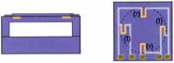

**Fig 15 - Piezo resistive pressure sensor or silicon cell**

This type of pressure sensor consists of a micro-machined silicon diaphragm with piezo resistive strain gauges diffused into it, fused to a silicon or glass back plate.

The resistors have a value of approx. 3.5 kOhm. Pressure induced strain increases the value of the radial resistors (r), and decreases the value of the resistors (t) transverse to the radius. This resistance change can be high as 30%.

Based on piezoelectric technology various physical quantities can be measured; the most common are pressure and acceleration. For pressure sensors, a thin [membrane](http://en.wikipedia.org/wiki/Artificial_membrane) and a massive base is used, ensuring that an applied pressure specifically loads the elements in one direction. For [accelerometers](http://en.wikipedia.org/wiki/Accelerometer), a [seismic mass](http://en.wikipedia.org/w/index.php?title=Seismic_mass&action=edit&redlink=1) is attached to the crystal elements. When the accelerometer experiences a motion, the invariant seismic mass loads the elements according to Newton’s second law of motion F=m a.

The main difference in the working principle between these two cases is the way forces are applied to the sensing elements. In a pressure sensor a thin membrane is used to transfer the force to the elements, while in accelerometers the forces are applied by an attached seismic mass.

Sensors often tend to be sensitive to more than one physical quantity. Pressure sensors show false signal when they are exposed to vibrations. Sophisticated pressure sensors therefore use acceleration compensation elements in addition to the pressure sensing elements. By carefully matching those elements, the acceleration signal (released from the compensation element) is subtracted from the combined signal of pressure and acceleration to derive the true pressure information.

Vibration sensors can also be used to harvest otherwise wasted energy from mechanical vibrations. This is accomplished by using piezoelectric materials to convert mechanical strain into usable electrical energy.

## **4.5.2 Types of pressure measurements**

[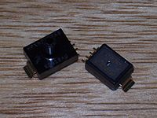](http://en.wikipedia.org/wiki/File:Pressure_sensors.jpg)

[](http://en.wikipedia.org/wiki/File:Pressure_sensors.jpg)  
**Fig 16- Silicon piezo resistive pressure sensors**

Pressure sensors can be classified in terms of pressure ranges they measure, temperature ranges of operation, and most importantly the type of pressure they measure. Pressure sensors are variously named according to their purpose, but the same technology may be used under different names.

* Absolute pressure sensor: This sensor measures the pressure relative to [perfect vacuum](http://en.wikipedia.org/wiki/Vacuum).
* Gauge pressure sensor: This sensor measures the pressure relative to [atmospheric pressure](http://en.wikipedia.org/wiki/Atmospheric_pressure). A tire pressure gauge is an example of gauge pressure measurement; when it indicates zero, then the pressure it is measuring is the same as the ambient pressure.
* Vacuum pressure sensor: This term can cause confusion. It may be used to describe a sensor that measures pressures below atmospheric pressure, showing the difference between that low pressure and atmospheric pressure (i.e. negative gauge pressure), but it may also be used to describe a sensor that measures low pressure relative to perfect vacuum (i.e. absolute pressure).
* Differential pressure sensor: This sensor measures the difference between two pressures, one connected to each side of the sensor. Differential pressure sensors are used to measure many properties, such as pressure drops across [oil filters](http://en.wikipedia.org/wiki/Oil_filter) or [air filters](http://en.wikipedia.org/wiki/Air_filter), fluid levels (by comparing the pressure above and below the liquid) or flow rates (by measuring the change in pressure across a restriction). Technically speaking, most pressure sensors are really differential pressure sensors; for example a gauge pressure sensor is merely a differential pressure sensor in which one side is open to the ambient atmosphere.
* Sealed pressure sensor: This sensor is similar to a gauge pressure sensor except that it measures pressure relative to some fixed pressure rather than the ambient atmospheric pressure (which varies according to the location and the weather).

## **4.5.3 Pressure-sensing technology**

There are two basic categories of analog pressure sensors.

Force collector types These types of electronic pressure sensors generally use a force collector (such a diaphragm, piston, bourdon tube, or bellows) to measure strain (or deflection) due to applied force (pressure) over an area.

* Piezoresistive strain gauge

Uses the [piezoresistive](http://en.wikipedia.org/wiki/Piezoresistive) effect of bonded or formed [strain gauges](http://en.wikipedia.org/wiki/Strain_gauge) to detect strain due to applied pressure. Common technology types are Silicon (Monocrystalline), Polysilicon Thin Film, Bonded Metal Foil, Thick Film, and Sputtered Thin Film. Generally, the strain gauges are connected to form a [Wheatstone bridge](http://en.wikipedia.org/wiki/Wheatstone_bridge) circuit to maximize the output of the sensor. This is the most commonly employed sensing technology for general purpose pressure measurement. Generally, these technologies are suited to measure absolute, gauge, vacuum, and differential pressures.

* Capacitive

Uses a diaphragm and pressure cavity to create a variable [capacitor](http://en.wikipedia.org/wiki/Capacitor) to detect strain due to applied pressure Common technologies use metal, ceramic, and silicon diaphragms. Generally, these technologies are most applied to low pressures (Absolute, Differential and Gauge)

* Electromagnetic

Measures the displacement of a diaphragm by means of changes in [inductance](http://en.wikipedia.org/wiki/Inductance) (reluctance), [LVDT](http://en.wikipedia.org/wiki/LVDT), [Hall Effect](http://en.wikipedia.org/wiki/Hall_Effect), or by [eddy current](http://en.wikipedia.org/wiki/Eddy_current) principle

* Piezoelectric

Uses the [piezoelectric](http://en.wikipedia.org/wiki/Piezoelectric) effect in certain materials such as quartz to measure the strain upon the sensing mechanism due to pressure this technology is commonly employed for the measurement of highly dynamic pressures.

* Optical

Techniques include the use of the physical change of an optical fiber to detect strain due to applied pressure. A common example of this type utilizes [Fiber Bragg Gratings](http://en.wikipedia.org/wiki/Fiber_Bragg_Grating). This technology is employed in challenging applications where the measurement may be highly remote, under high temperature, or may benefit from technologies inherently immune to electromagnetic interference. Another analogous technique utilizes an elastic film constructed in layers that can change reflected wavelengths according to the applied pressure (strain).[[1]](http://en.wikipedia.org/wiki/Pressure_sensor#cite_note-0).

* Potentiometric

Uses the motion of a wiper along a resistive mechanism to detect the strain caused by applied pressure

## **4.5.4 Applications**

There are many applications for pressure sensors:

* **Pressure sensing**

This is where the measurement of interest is [pressure](http://en.wikipedia.org/wiki/Pressure), expressed as a [force](http://en.wikipedia.org/wiki/Force) per unit area (. This is useful in weather instrumentation, aircraft, automobiles, and any other machinery that has pressure functionality implemented.

* **Altitude sensing**

This is useful in aircraft, rockets, satellites, weather balloons, and many other applications. All these applications make use of the relationship between changes in pressure relative to the altitude. Barometric pressure sensors can have an altitude resolution of less than 1 meter, which is significantly better than GPS systems (about 20 meters altitude resolution). In navigation applications altimeters are used to distinguish between stacked road levels for car navigation and floor levels in buildings for pedestrian navigation.

* **Flow sensing**

This is the use of pressure sensors in conjunction with the [venturi effect](http://en.wikipedia.org/wiki/Venturi_effect) to measure flow. Differential pressure is measured between two segments of a venturi tube that have a different aperture. The pressure difference between the two segments is directly proportional to the flow rate through the venturi tube. A low pressure sensor is almost always required as the pressure difference is relatively small.

* **Level / depth sensing**

A pressure sensor may also be used to calculate the level of a fluid. This technique is commonly employed to measure the depth of a submerged body (such as a diver or submarine), or level of contents in a tank (such as in a water tower). For most practical purposes, fluid level is directly proportional to pressure. In the case of fresh water where the contents are under atmospheric pressure, 1psi = 27.7 inH20 / 1Pa = 9.81 mmH20. The basic equation for such a measurement is

P = pgh \,

where *P* = pressure, *p* = density of the fluid, *g* = standard gravity, *h* = height of fluid column above pressure sensor

* **Leak testing**

A pressure sensor may be used to sense the decay of pressure due to a system leak. This is commonly done by either comparison to a known leak using differential pressure, or by means of utilizing the pressure sensor to measure pressure change over time.

**4.6 REGULATED POWER SUPPLY:**

**4.6.1 Introduction:**

Power supply is a supply of electrical power. A device or system that supplies electrical or other types of energy to an output load or group of loads is called a power supply unit or PSU. The term is most commonly applied to electrical energy supplies, less often to mechanical ones, and rarely to others.

A power supply may include a power distribution system as well as primary or secondary sources of energy such as

* Conversion of one form of electrical power to another desired form and voltage, typically involving converting AC line voltage to a well-regulated lower-voltage DC for electronic devices. Low voltage, low power DC power supply units are commonly integrated with the devices they supply, such as computers and household electronics.
* Batteries.
* Chemical fuel cells and other forms of energy storage systems.
* Solar power.
* Generators or alternators.

**4.6.2 Block Diagram:**

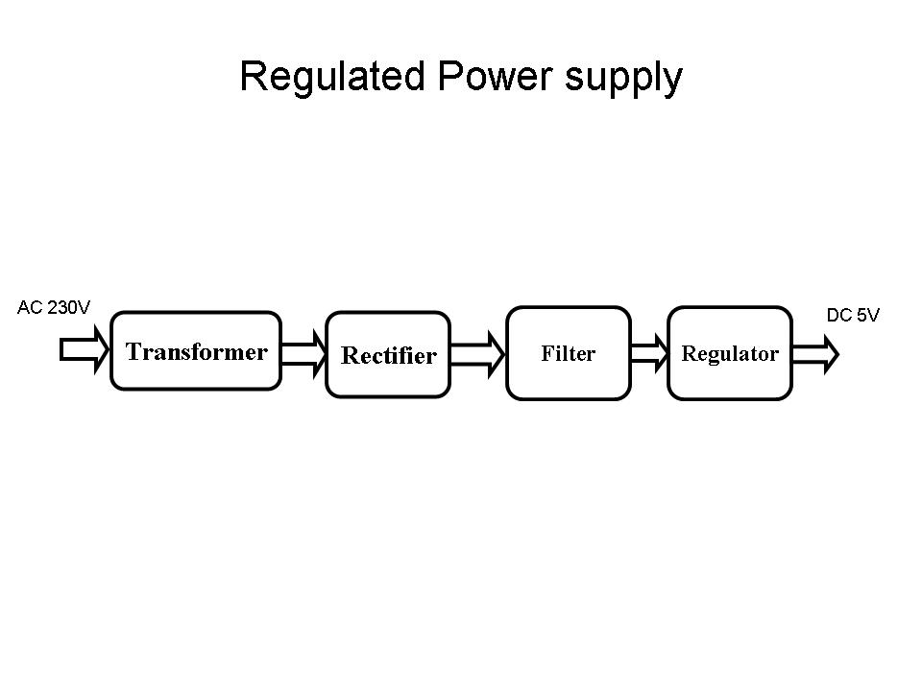

The basic circuit diagram of a regulated power supply (DC O/P) with led connected as load is shown below

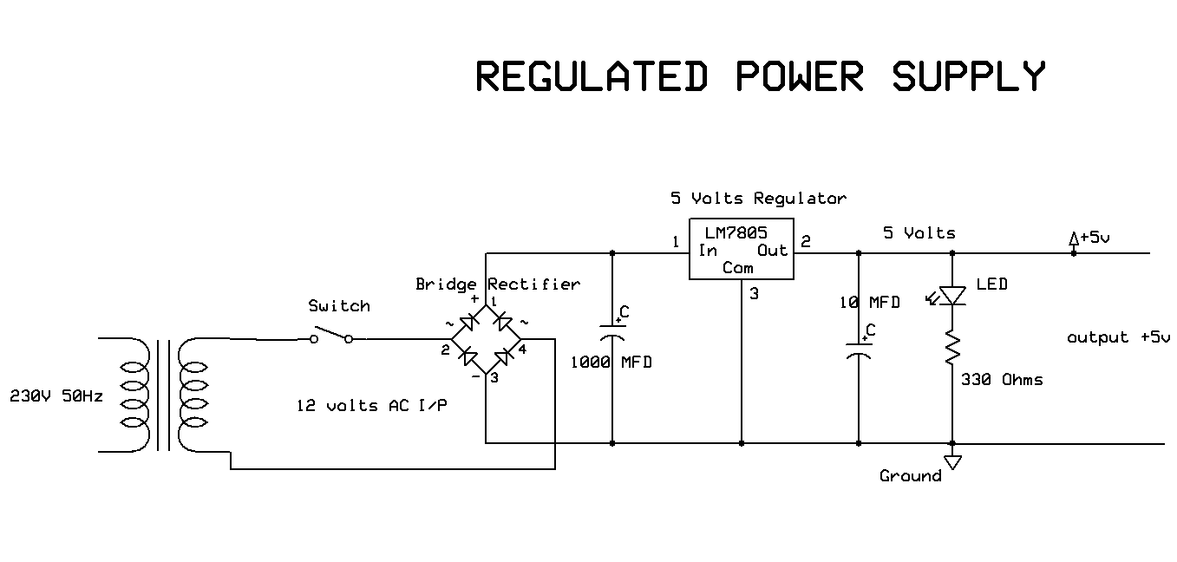

The components mainly used in above figure are

* 230V AC MAINS
* TRANSFORMER
* BRIDGE RECTIFIER(DIODES)
* CAPACITOR
* VOLTAGE REGULATOR(IC 7805)
* RESISTOR
* LED(LIGHT EMITTING DIODE)

**4.6.3 LED:**

A light-emitting diode (LED) is a semiconductor light source. LED’s are used as indicator lamps in many devices, and are increasingly used for lighting. Introduced as a practical electronic component in 1962, early LED’s emitted low-intensity red light, but modern versions are available across the visible, ultraviolet and infrared wavelengths, with very high brightness. The internal structure and parts of a led are shown in figures 3.15 and 3.16 respectively.

1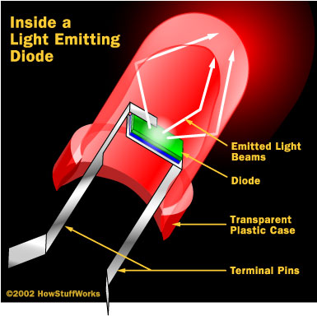 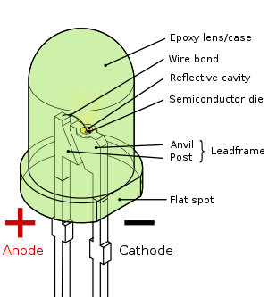

**Fig 17: Parts of a LED**

**Working:**

The structure of the LED light is completely different than that of the light bulb. Amazingly, the LED has a simple and strong structure. The light-emitting semiconductor material is what determines the LED's color. The LED is based on the semiconductor diode.

When a diode is forward biased (switched on), electrons are able to recombine with holes within the device, releasing energy in the form of photons. This effect is called electroluminescence and the color of the light (corresponding to the energy of the photon) is determined by the energy gap of the semiconductor. An LED is usually small in area (less than 1 mm2), and integrated optical components are used to shape its radiation pattern and assist in reflection. LED’s present many advantages over incandescent light sources including lower energy consumption, longer lifetime, improved robustness, smaller size, faster switching, and greater durability and reliability. However, they are relatively expensive and require more precise current and heat management than traditional light sources. Current LED products for general lighting are more expensive to buy than fluorescent lamp sources of comparable output. They also enjoy use in applications as diverse as replacements for traditional light sources in automotive lighting (particularly indicators) and in traffic signals. The compact size of LED’s has allowed new text and video displays and sensors to be developed, while their high switching rates are useful in advanced communications technology. The electrical symbol and polarities of led are shown in fig: 3.17.

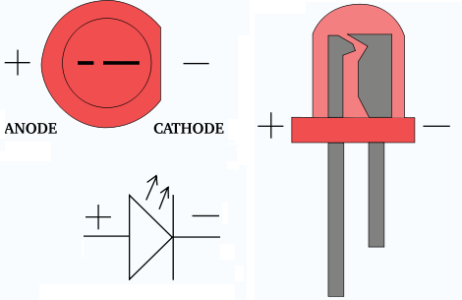

**Fig 18: Electrical Symbol & Polarities of LED**

LED lights have a variety of advantages over other light sources:

* High-levels of brightness and intensity
* High-efficiency
* Low-voltage and current requirements
* Low radiated heat
* High reliability (resistant to shock and vibration)
* No UV Rays
* Long source life
* Can be easily controlled and programmed

**Applications of LED** fall into three major categories:

* Visual signal application where the light goes more or less directly from the LED to the human eye, to convey a message or meaning.
* Illumination where LED light is reflected from object to give visual response of these objects.
* Generate light for measuring and interacting with processes that do not involve the human visual system.

**4.6.4 Voltage Regulator:**

A voltage regulator (also called a ‘regulator’) with only three terminals appears to be a simple device, but it is in fact a very complex integrated circuit. It converts a varying input voltage into a constant ‘regulated’ output voltage. Voltage Regulators are available in a variety of outputs like 5V, 6V, 9V, 12V and 15V. The LM78XX series of voltage regulators are designed for positive input. For applications requiring negative input, the LM79XX series is used. Using a pair of ‘voltage-divider’ resistors can increase the output voltage of a regulator circuit.

It is not possible to obtain a voltage lower than the stated rating. You cannot use a 12V regulator to make a 5V power supply. Voltage regulators are very robust. These can withstand over-current draw due to short circuits and also over-heating. In both cases, the regulator will cut off before any damage occurs. The only way to destroy a regulator is to apply reverse voltage to its input. Reverse polarity destroys the regulator almost instantly. Fig: 3.12 shows voltage regulator.



**Fig 19: Voltage Regulator**

**4.6.5 Resistors:**

A resistor is a two-terminal electronic component that produces a voltage across its terminals that is proportional to the electric current passing through it in accordance with Ohm's law:

*V* = *IR*

Resistors are elements of electrical networks and electronic circuits and are ubiquitous in most electronic equipment. Practical resistors can be made of various compounds and films, as well as resistance wire (wire made of a high-resistivity alloy, such as nickel/chrome).

The primary characteristics of a resistor are the resistance, the tolerance, maximum working voltage and the power rating. Other characteristics include temperature coefficient, noise, and inductance. Less well-known is critical resistance, the value below which power dissipation limits the maximum permitted current flow, and above which the limit is applied voltage. Critical resistance is determined by the design, materials and dimensions of the resistor.

Resistors can be made to control the flow of current, to work as Voltage dividers, to dissipate power and it can shape electrical waves when used in combination of other components. Basic unit is ohms.

**Theory of operation:**

Ohm's law:

The behavior of an ideal resistor is dictated by the relationship specified in Ohm's law:

V = IR

Ohm's law states that the voltage (V) across a resistor is proportional to the current (I) through it where the constant of proportionality is the resistance (R).

Power dissipation:

The power dissipated by a resistor (or the equivalent resistance of a resistor network) is calculated using the following:

P = I^2 R = I V = \frac{V^2}{R}

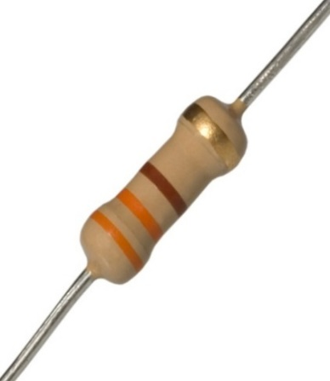

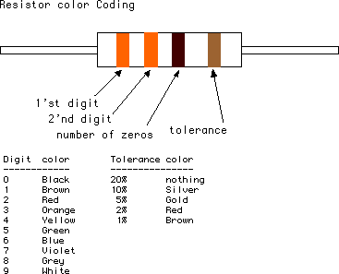

**Fig 20 : Resistor**

**4.6.6 Rectification:**

The process of converting an alternating current to a pulsating direct current is called as rectification. For rectification purpose we use rectifiers.

**Rectifiers:**

A rectifier is an electrical device that converts alternating current (AC) to direct current (DC), a process known as rectification. Rectifiers have many uses including as components of power supplies and as detectors of radio signals. Rectifiers may be made of solid-state diodes, vacuum tube diodes, mercury arc valves, and other components.

A device that it can perform the opposite function (converting DC to AC) is known as an inverter.

When only one diode is used to rectify AC (by blocking the negative or positive portion of the waveform), the difference between the term diode and the term rectifier is merely one of usage, i.e., the term rectifier describes a diode that is being used to convert AC to DC. Almost all rectifiers comprise a number of diodes in a specific arrangement for more efficiently converting AC to DC than is possible with only one diode. Before the development of silicon semiconductor rectifiers, vacuum tube diodes and copper (I) oxide or selenium rectifier stacks were used.

**Bridge full wave rectifier:**

The Bridge rectifier circuit is shown in fig:3.8, which converts an ac voltage to dc voltage using both half cycles of the input ac voltage. The Bridge rectifier circuit is shown in the figure. The circuit has four diodes connected to form a bridge. The ac input voltage is applied to the diagonally opposite ends of the bridge. The load resistance is connected between the other two ends of the bridge.

For the positive half cycle of the input ac voltage, diodes D1 and D3 conduct, whereas diodes D2 and D4 remain in the OFF state. The conducting diodes will be in series with the load resistance RL and hence the load current flows through RL.

For the negative half cycle of the input ac voltage, diodes D2 and D4 conduct whereas, D1 and D3 remain OFF. The conducting diodes D2 and D4 will be in series with the load resistance RL and hence the current flows through RL in the same direction as in the previous half cycle. Thus a bi-directional wave is converted into a unidirectional wave. 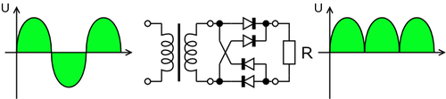

**4.7 GEAR BOX**

A gear motor designed as an all-in-one combination of a motor and gearbox. This gearbox addition at the head to a motor comparatively reduces the speed while increasing the torque output. Also known as the Centre Shaft DC Geared Motors as their shaft extends through the center of their gearbox assembly. This square Gear/Geared Motor 10 RPM – High Torque 12v DC provides torque greater as compared to Johnson Geared Motors and consumes less current as well. This geared motor is popular due to its higher durability and is able to work for hours at a time. This geared motor operates at a Base motor RPM of 3000.

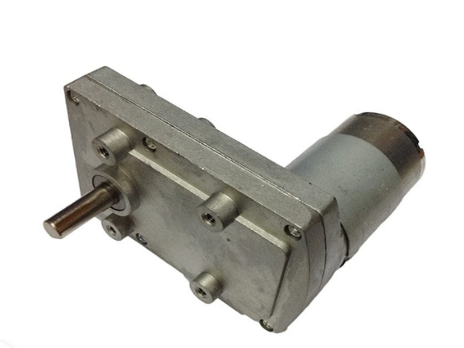

**Fig 21 : 10 rpm gear box with dc motor**

This Square Gear / Geared Motor – High Torque 10 rpm 12v DC widely used for industrial applications. They offer a wide range of applications makes it perfect for DIY project makers as well as small business machines. This Square Gear / Geared Motor 10 RPM, 12v designed as a simple DC motor with a metal gearbox attached to it. This metal gearbox used for driving the shaft of the motor. So in short it is a mechanically commutated electric motor powered via DC supply. These Motors are also prominent for their compact size and massive torque-speed characteristic.

These Geared Motor that with a side shaft is known as an off-centered shaft and four M4 mounting holes. Here the shaft of the motor develops metal bushes which makes these DC gear motors Shaft wear-resistant. And also the shaft of the motor has a hole for better coupling. This motor operates smoothly between the voltage range 6 to 15 V DC and gives you 10 RPM at 12V supply. It provides a torque of 90kg-cm at 10 RPM.

**FEATURES**:

* Operating Voltage: 12 V DC
* No Load Current: ≤220 mA
* No load Speed: 10 RPM (at 12V)
* Full Load Current: ≤1300mA
* Rated Current: ≤4800 mA
* Rated Torque: 90 Kg-cm
* Shaft Length: 27 mm
* Shaft Diameter: 8 mm
* Length: 92mm
* Dimension Overall: 70 X 70 (Sq.) X 90 (Length)
* Heavy Duty Metal Gears.
* Uniformity of parts.
* Capability to absorb shock and vibration as a result of elastic compliance.
* Ability to operate with minimum or no lubrication, due to inherent lubricity.
* Relatively low coefficient of friction.
* Corrosion-resistance; elimination of plating, or protective coatings.

**APPLICATIONS**:

* Robotic purposes.
* Central air – conditioning valve
* Coin refund devices
* Industrial applications

**4.8 BEVEL GEARS**

A bevel gear is a toothed rotating machine element used to transfer mechanical energy or shaft power between shafts that are intersecting, either perpendicular or at an angle. This results in a change in the axis of rotation of the shaft power. Aside from this function, bevel gears can also increase or decrease torque while producing the opposite effect on the angular speed.

**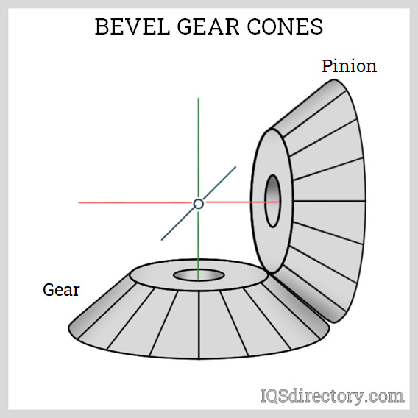  
Fig 22 – Bevel Gear Cones**

A bevel gear can be imagined as a truncated cone. On its lateral side, teeth that have been milled interlock with other gears with their own sets of teeth. The gear transmitting the shaft power is called the driver gear, while the gear where power is being transmitted is called the driven gear. The number of teeth of the driver and driven gear is usually different to produce a mechanical advantage. The ratio between the number of teeth of the driven to the driver gear is known as the gear ratio, while the mechanical advantage is the ratio of the output torque to the input torque. This relationship is shown by the following equation:

 MA=Tb/Ta = rb/ra = Nb/Na

MA is the mechanical advantage, τb and τa are the torques, rb and ra are the radii, and Nb and Na are the numbers of teeth of the driven and driver gears, respectively. From the equation, it can be seen that increasing the number of teeth of the driven gear produces a larger output torque.

On the other hand, producing a larger mechanical advantage decreases the driven gear's output speed. This is expressed by the equation:

  MA=Wa / Wb

ωª and ωb are the driver and driven gears‘ angular speeds, respectively. In general, a gear ratio of 10:1 is recommended for a bevel gear set. For increasing the speed of the driven gears, a gear ratio of 1:5 is suggested.

**Types of Bevel gears**

### Straight Bevel Gears

A straight bevel gear is the simplest form of a bevel gear. The teeth are in a straight line that intersects at the axis of the gear when extended. The teeth are tapered in thickness, making the outer, or heel part of the tooth larger than the inner part, or toe. Straight bevel gears have instantaneous lines of contact, permitting more tolerance in mounting. A downside to using this type is the vibration and noise. This limits straight bevel gears to low-speed and static loading applications. CA common application of straight bevel gears is differential systems in automotive vehicles.

### Spiral Bevel Gears

A spiral bevel gear is the most complex form of bevel gear. The teeth of spiral gears are curved and oblique, in contrast to the teeth orientation of straight bevel gears. This results in more overlap between teeth, which promotes gradual engagement and disengagement upon tooth contact. This improved smoothness results in minimal vibration and noise produced during operation. Also, because of higher load sharing from more teeth in contact, spiral bevel gears have better load capacities. This allows them to be smaller compared to straight bevel gears with the same capacity.

### Zerol Bevel Gears

This type is a modification of a straight bevel gear trademarked by Gleason Works. Zerol gears have teeth curved in a lengthwise direction. These gears are also somewhat similar to spiral bevel gears in their profile. Their difference is the spiral angle; Zerol types have 0° spiral angles, while spiral types have 35°.

* Hypoid Bevel Gears

A hypoid bevel gear is a special type of bevel gears in which the axes of the shafts are not intersecting nor parallel. The distance between the two gear axes is called the offset. The teeth of hypoid bevel gears are helical, similar to spiral bevel gears. A hypoid bevel gear designed with no offset is simply a spiral bevel gear. The manufacture and shaping of hypoid types are similar to spiral bevel gears.

### Miter Bevel Gears

This is a type of bevel gear with a gear ratio of 1:1, meaning the driver and driven gears have the same number of teeth. Because a miter gear does not produce any mechanical advantage, the function of this type is limited to changing the axis or rotation. Usually, miter gears have axes that intersect perpendicularly. In some assemblies, The shafts are aligned to intersect at any angle. These are known as angular miter bevel gears. Shaft angles of angular miter bevel gears can range from 45° to 120°. Miter bevel gear teeth cuts can be straight, spiral, or Zerol.

**4.9 MICROCONTROLLER**

A Microcontroller is a programmable digital processor with necessary peripherals. Both microcontrollers and microprocessors are complex sequential digital circuits meant to carry out job according to the program / instructions. Sometimes analog input/output interface makes a part of microcontroller circuit of mixed mode (both analog and digital nature).

1. A smaller computer

2. On-chip RAM, ROM, I/O ports...

Example: Motorola’s 6811, Intel’s 8051, Zilog’s Z8 and PIC 16X

**General-purpose microprocessor**

1. CPU for Computers

2. No RAM, ROM, I/O on CPU chip itself

3. Example: Intel’s x86, Motorola’s 680x0

**4.9.1 Microprocessor vs. Microcontroller**

Microcontroller differs from a microprocessor in many ways. First and the most important is its functionality. In order for a microprocessor to be used, other components such as memory, or components for receiving and sending data must be added to it. In short that means that microprocessor is the very heart of the computer. On the other hand, microcontroller is designed to be all of that in one. No other external components are needed for its application because all necessary peripherals are already built into it. Thus, we save the time and space needed to construct devices.

**Microprocessor**

* CPU is stand-alone, RAM, ROM, I/O, timer are separate
* Designer can decide on the amount of ROM, RAM and I/O ports.
* expansive
* versatility
* general-purpose

**Microcontroller**

* CPU, RAM, ROM, I/O and timer are all on a single chip
* fix amount of on-chip ROM, RAM, I/O ports
* for applications in which cost, power and space are critical
* single-purpose

**Choosing a MC**

* Speed
* Packaging(Ex. DIP,QFP Quad Flat Package)
* Power Consumption
* Amount of RAM,ROM
* I/O Pins
* Final Cost of The product
* How easy it is Upgraded

**4.9.2 Memory types**

In a microcontroller, two types of memory are found. They are, program memory and data memory respectively. Program memory is also known as 'control store' and 'firm ware'. It is non-volatile i.e, the memory content is not lost when the power goes off. Non-volatile memory is also called Read Only Memory (ROM). There are various types of ROM.

1. **Mask ROM:** Some microcontrollers with ROM are programmed while they are still in the factory. This ROM is called Mask ROM. Since the microcontrollers with Mask ROM are used for specific application, there is no need to reprogram them. Some times, this type of manufacturing reduces the cost for bulk production.

**2. Reprogrammable program memory (or) Erasable PROM (EPROM):** Microcontrollers with EPROM were introduced in late 1970's. These devices are electrically programmable but are erased with UV radiation. The construction of a EPROM memory cell is somewhat like a MOSFET but with a control and float semiconductor as shown in the figure.

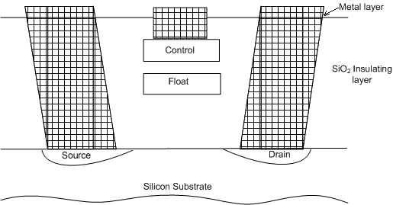

**Fig 23 – Internal working of EPROM**

In the unprogrammed state, the 'float' does not have any charge and the MOSFET is in the OFF state. To program the cell, the 'control' above the 'float' is raised to a high enough potential such that a charge leaks to the float through SiO2 insulating layer. Hence a channel is formed between 'Source' and 'Drain' in the silicon substrate and the MOSFET ­­ becomes 'ON'. The charge in the 'float' remains for a long time (typically over 30 years). The charge can be removed by exposing the float to UV radiation. For UV erasable version, the packaging is done in a ceramic enclosure with a glass window.

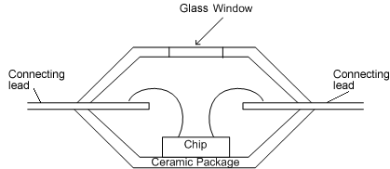

**Fig 24 –Chamber arrangement of EPROM**

**3. OTP EPROM:** One time programmable (OTP) EPROM based microcontrollers do not have any glass window for UV erasing.  These can be programmed only once. This type of packaging results in microcontroller that have the cost 10% of the microcontrollers with UV erase facility (i.e., 1/10th cost).

**4**. **EEPROM**: (Electrically Erasable Programmable ROM): This is similar to EPROM but the float charge can be removed electrically.

**5**.  **FLASH (EEPROM Memory)**: FLASH memory was introduced by INTEL in late 1980's.

This memory is similar to EEPROM but the cells in a FLASH memory are bussed so that they can be erased in a few clock cycles. Hence the reprogramming is faster.

**4.9.3 Different Data memory types:**

1. Random access memory (RAM)

2. Read only memory (ROM)

**Random access memory (RAM): data will disappear after power down.**

* + Static RAM (SRAM): each bit is a flip-flop, fast but expensive.
  + Dynamic RAM (DRAM): each bit is a small capacitor, and is needed to be recharged regularly, slower but cheap. To be used as primary memory in a computer.

Data memory can be classified into the following categories

* Bits
* Registers
* Variable RAM
* Program counter stack

Microcontroller can have ability to perform manipulation of individual bits in certain registers (bit manipulation). This is a unique feature of a microcontroller, not available in a microprocessor.

Eight bits make a byte. Memory bytes are known as file registers.

Registers are some special RAM locations that can be accessed by the processor very easily.

**4.9.4 PIC Microcontrollers:**

PIC stands for Peripheral Interface Controller given by Microchip Technology to identify its single-chip microcontrollers. These devices have been very successful in 8-bit microcontrollers. The main reason is that Microchip Technology has continuously upgraded the device architecture and added needed peripherals to the microcontroller to suit customers' requirements. The development tools such as assembler and simulator are freely available on the internet at www.microchip.com .

**Low - end PIC Architectures:**

Microchip PIC microcontrollers are available in various types. When PIC microcontroller MCU was first available from General Instruments in early 1980's, the microcontroller consisted of a simple processor executing 12-bit wide instructions with basic I/O functions. These devices are known as low-end architectures. They have limited program memory and are meant for applications requiring simple interface functions and small program & data memories. Some of the low-end device numbers are

12C5XX   
16C5X   
16C505

**Mid range PIC Architectures**

Mid range PIC architectures are built by upgrading low-end architectures with more number of peripherals, more number of registers and more data/program memory. Some of the mid-range devices are

16C6X   
16C7X   
16F87X

Program memory type is indicated by an alphabet.

C = EPROM

F = Flash

RC = Mask ROM

Popularity of the PIC microcontrollers is due to the following factors.

1. Speed: Harvard Architecture, RISC architecture, 1 instruction cycle = 4 clock cycles.
2. Instruction set simplicity: The instruction set consists of just 35 instructions (as opposed to 111 instructions for 8051).
3. Power-on-reset and brown-out reset. Brown-out-reset means when the power supply goes below a specified voltage (say 4V), it causes PIC to reset; hence malfunction is avoided.

A watch dog timer (user programmable) resets the processor if the software/program ever malfunctions and deviates  from its normal operation.

1. PIC microcontroller has four optional clock sources.
   * Low power crystal
   * Mid range crystal
   * High range crystal
   * RC oscillator (low cost).
2. Programmable timers and on-chip ADC.
3. Up to 12 independent interrupt sources.
4. Powerful output pin control (25 mA (max.) current sourcing capability per pin.)
5. EPROM/OTP/ROM/Flash memory option.
6. I/O port expansion capability.

Free assembler and simulator support from Microchip at www.microchip.com

**4.9.5 CPU Architecture:**

The CPU uses Harvard architecture with separate Program and Variable (data) memory interface. This facilitates instruction fetch and the operation on data/accessing of variables simultaneously.

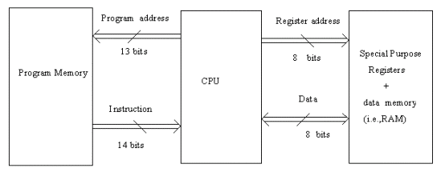

**Fig 25- Architecture of PIC microcontroller**

**PIC Microcontroller Clock**

Most of the PIC microcontrollers can operate up to 20MHz. One instructions cycle (machine cycle) consists of four clock cycles

Relation between instruction cycles and clock cycles for PIC microcontrollers

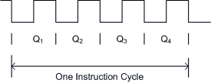

Instructions that do not require modification of program counter content get executed in one instruction cycle.

**Memory unit**

Memory is part of the microcontroller whose function is to store data.   
The easiest way to explain it is to describe it as one big closet with lots of drawers. If we suppose that we marked the drawers in such a way that they can not be confused, any of their contents will then be easily accessible. It is enough to know the designation of the drawer and so its contents will be known to us for sure.

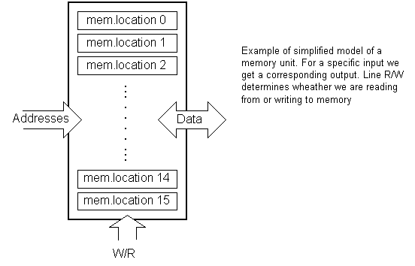

Memory components are exactly like that. For a certain input we get the contents of a certain addressed memory location and that's all. Two new concepts are brought to us: addressing and memory location. Memory consists of all memory locations, and addressing is nothing but selecting one of them. This means that we need to select the desired memory location on one hand, and on the other hand we need to wait for the contents of that location. Besides reading from a memory location, memory must also provide for writing onto it. This is done by supplying an additional line called control line. We will designate this line as R/W (read/write). Control line is used in the following way: if r/w=1, reading is done, and if opposite is true then writing is done on the memory location.

Memory is the first element, and we need a few operation of our microcontroller.

**Central Processing Unit**

Let add 3 more memory locations to a specific block that will have a built in capability to multiply, divide, subtract, and move its contents from one memory location onto another. The part we just added in is called "central processing unit" (CPU). Its memory locations are called registers.

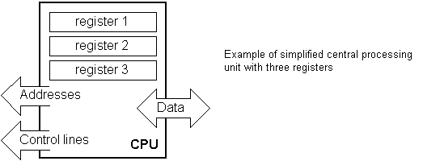

**Fig 26 – Memory unit in CPU**

Registers are therefore memory locations whose role is to help with performing various mathematical operations or any other operations with data wherever data can be found. Look at the current situation. We have two independent entities (memory and CPU) which are interconnected, and thus any exchange of data is hindered, as well as its functionality. If, for example, we wish to add the contents of two memory locations and return the result again back to memory, we would need a connection between memory and CPU. Simply stated, we must have some "way" through data goes from one block to another.

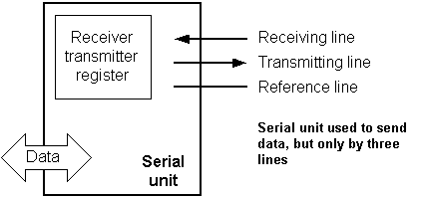

As we have separate lines for receiving and sending, it is possible to receive and send data (info.) at the same time. So called full-duplex mode block which enables this way of communication is called a serial communication block. Unlike the parallel transmission, data moves here bit by bit, or in a series of bits what defines the term serial communication comes from. After the reception of data we need to read it from the receiving location and store it in memory as opposed to sending where the process is reversed. Data goes from memory through the bus to the sending location, and  then to the receiving unit according to the protocol.

**Physical configuration of the interior of a microcontroller**

Thin lines which lead from the center towards the sides of the microcontroller represent wires connecting inner blocks with the pins on the housing of the microcontroller so called bonding lines. Chart on the following page represents the center section of a microcontroller.

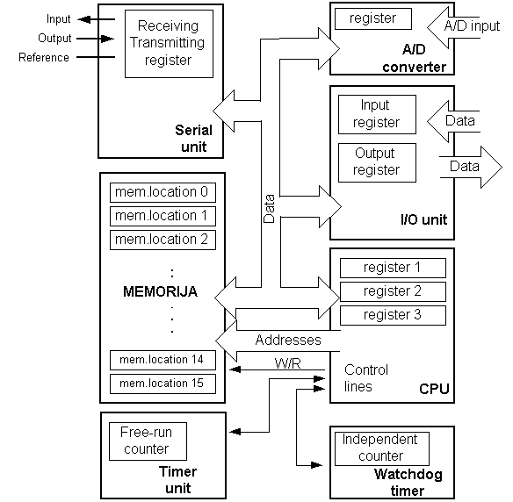

**Fig 27 – Center section of microcontroller**

**Microcontroller outline with its basic elements and internal connections**

For a real application, a microcontroller alone is not enough. Beside a microcontroller, we need a program that would be executed, and a few more elements which make up a interface logic towards the elements of regulation (which will be discussed in later chapters).

The program adds the contents of two memory locations, and views their sum on port A. The first line of the program stands for moving the contents of memory location "A" into one of the registers of central processing unit. As we need the other data as well, we will also move it into the other register of the central processing unit. The next instruction instructs the central processing unit to add  the contents of those two registers and send a result  to port A, so that sum of that addition would be visible to the outside world. For a more complex problem, program that works on its solution will be bigger. Programming can be done in several languages such as Assembler, C and Basic which are most commonly used languages. Assembler belongs to lower level languages that are programmed slowly, but take up the least amount of space in memory and gives the best results where the speed of program execution is concerned. As it is the most commonly used language in programming microcontrollers it will be discussed in a later chapter. Programs in C language are easier to be written, easier to be understood, but are slower in executing from assembler programs. Basic is the easiest one to learn, and its instructions are nearest a man's way of reasoning, but like C programming language it is also slower than assembler. In any case, before you make up your mind about one of these languages you need to consider carefully the demands for execution speed, for the size of memory and for the amount of time available for its assembly.

After the program is written, we would install the microcontroller into a device and run it. In order to do this we need to add a few more external components necessary for its work. First we must give life to a microcontroller by connecting it to a power supply (power needed for operation of all electronic instruments) and oscillator whose role is similar to the role that heart plays in a human body. Based on its clocks microcontroller executes instructions of a program. As it receives supply microcontroller will perform a small check up on itself, look up the beginning of the program and start executing it. How the device will work depends on many parameters, the most important of which is the skillfulness of the developer of hardware, and on programmer's expertise in getting the maximum out of the device with his program.

**4.9.6 Pin description**

PIC16F72 has a total of 28 pins. It is most frequently found in a DIP28 type of case but can also be found in SMD case which is smaller from a DIP. DIP is an abbreviation for Dual In Package. SMD is an abbreviation for Surface Mount Devices suggesting that holes for pins to go through when mounting aren't necessary in soldering this type of a component.

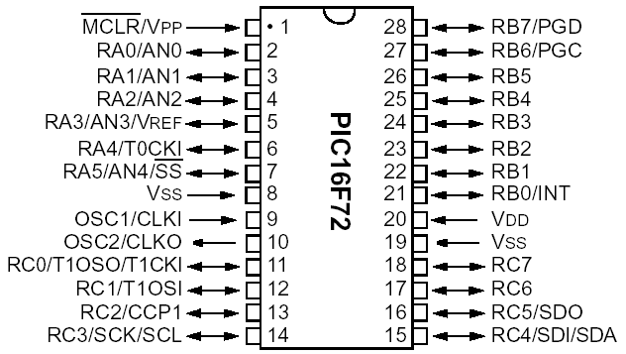

**Fig 28 – Pins on PIC16F72**

Pins on PIC16F72 microcontroller have the following meaning:  
  
There are 28 pins on PIC16F72. Most of them can be used as an IO pin. Others are already for specific functions. These are the pin functions.  
1. MCLR – to reset the PIC  
2. RA0 – port A pin 0  
3. RA1 – port A pin 1  
4. RA2 – port A pin 2  
5. RA3 – port A pin 3  
6. RA4 – port A pin 4  
7. RA5 – port A pin 5  
8. VSS – ground  
9. OSC1 – connect to oscillator  
10. OSC2 – connect to oscillator  
11. RC0 – port C pin 0 VDD – power supply  
12. RC1 – port C pin 1  
13. RC2 – port C pin 2  
14. RC3 – port C pin 3  
15. RC4 - port C pin 4  
16. RC5 - port C pin 5  
17. RC6 - port C pin 6  
18. RC7 - port C pin 7  
19. VSS - ground  
20. VDD – power supply  
21. RB0 - port B pin 0  
22. RB1 - port B pin 1  
23. RB2 - port B pin 2  
24. RB3 - port B pin 3  
25. RB4 - port B pin 4  
26. RB5 - port B pin 5  
27. RB6 - port B pin 6  
28. RB7 - port B pin 7  
  
By utilizing all of this pin so many application can be done such as:  
1. LCD – connect to Port B pin.  
2. LED – connect to any pin declared as output.  
3. Relay and Motor - connect to any pin declared as output.  
4. External EEPROM – connect to I2C interface pin – RC3 and RC4 (SCL and SDA)   
5. LDR, Potentiometer and sensor – connect to analogue input pin such as RA0.  
6. GSM modem dial up modem – connect to RC6 and RC7 – the serial communication interface using RS232 protocol.

For more detail function for each specific pin please refer to the device datasheet from Microchip.

**Ports**

Term "port" refers to a group of pins on a microcontroller which can be accessed simultaneously, or on which we can set the desired combination of zeros and ones, or read from them an existing status. Physically, port is a register inside a microcontroller which is connected by wires to the pins of a microcontroller. Ports represent physical connection of Central Processing Unit with an outside world. Microcontroller uses them in order to monitor or control other components or devices. Due to functionality, some pins have twofold roles like PA4/TOCKI for instance, which is in the same time the fourth bit of port A and an external input for free-run counter. Selection of one of these two pin functions is done in one of the configuration registers. An illustration of this is the fifth bit T0CS in OPTION register. By selecting one of the functions the other one is disabled.

All port pins can be designated as input or output, according to the needs of a device that's being developed. In order to define a pin as input or output pin, the right combination of zeros and ones must be written in TRIS register. If the appropriate bit of TRIS register contains logical "1", then that pin is an input pin, and if the opposite is true, it's an output pin. Every port has its proper TRIS register. Thus, port A has TRISA, and port B has TRISB. Pin direction can be changed during the course of work which is particularly fitting for one-line communication where data flow constantly changes direction. PORTA and PORTB state registers are located in bank 0, while TRISA and TSRIB pins are located in bank 1 which can be seen in the below intimated figure . \  
**Program memory**

Program memory has been carried out in FLASH technology which makes it possible to program a microcontroller many times before it's installed into a device, and even after its installment if eventual changes in program or process parameters should occur. The size of program memory is 1024 locations with 14 bits width where locations zero and four are reserved for reset and interrupt vector.

**Data memory:**

Data memory consists of EEPROM and RAM memories. EEPROM memory consists of 256 eight bit locations whose contents are not lost during loosing of power supply. EEPROM is not directly addressable, but is accessed indirectly through EEADR and EEDATA registers. As EEPROM memory usually serves for storing important parameters (for example, of a given temperature in temperature regulators) , there is a strict procedure for writing in EEPROM which must be followed in order to avoid accidental writing. RAM memory for data occupies space on a memory map from location 0x0C to 0x4F which comes to 68 locations. Locations of RAM memory are also called GPR registers which is an abbreviation for *General Purpose Registers*. GPR registers can be accessed regardless of which bank is selected at the moment.

**4.9.7 Applications**

PIC16F72 perfectly fits many uses, from automotive industries and controlling home appliances to industrial instruments, remote sensors, electrical door locks and safety devices. It is also ideal for smart cards as well as for battery supplied devices because of its low consumption.

EEPROM memory makes it easier to apply microcontrollers to devices where permanent storage of various parameters is needed (codes for transmitters, motor speed, receiver frequencies, etc.). Low cost, low consumption, easy handling and flexibility make PIC16F72 applicable even in areas where microcontrollers had not previously been considered (example: timer functions, interface replacement in larger systems, coprocessor applications, etc.).

In System Programmability of this chip (along with using only two pins in data transfer) makes possible the flexibility of a product, after assembling and testing have been completed. This capability can be used to create assembly-line production, to store calibration data available only after final testing, or it can be used to improve programs on finished products.

**4.10 LCD DISPLAY**

**4.10.1 LCD Background:**

One of the most common devices attached to a micro controller is an LCD display. Some of the most common LCD’s connected to the many microcontrollers are 16x2 and 20x2 displays. This means 16 characters per line by 2 lines and 20 characters per line by 2 lines, respectively.

**Basic 16x 2 Characters LCD**

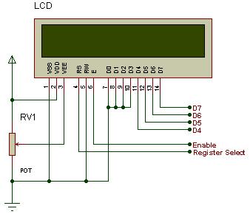

**Fig 29 – LCD configuration**

**4.10.2 Pin description:**

|  |  |  |
| --- | --- | --- |
| **Pin No.** | **Name** | **Description** |
| Pin no. 1 | **VSS** | Power supply (GND) |
| Pin no. 2 | **VCC** | Power supply (+5V) |
| Pin no. 3 | **VEE** | Contrast adjust |
| Pin no. 4 | **RS** | 0 = Instruction input 1 = Data input |
| Pin no. 5 | **R/W** | 0 = Write to LCD module 1 = Read from LCD module |
| Pin no. 6 | **EN** | Enable signal |
| Pin no. 7 | **D0** | Data bus line 0 (LSB) |
| Pin no. 8 | **D1** | Data bus line 1 |
| Pin no. 9 | **D2** | Data bus line 2 |
| Pin no. 10 | **D3** | Data bus line 3 |
| Pin no. 11 | **D4** | Data bus line 4 |
| Pin no. 12 | **D5** | Data bus line 5 |
| Pin no. 13 | **D6** | Data bus line 6 |
| Pin no. 14 | **D7** | Data bus line 7 (MSB) |

**Table 1: Character LCD pins with Microcontroller**

The LCD requires 3 control lines as well as either 4 or 8 I/O lines for the data bus. The user may select whether the LCD is to operate with a 4-bit data bus or an 8-bit data bus. If a 4-bit data bus is used the LCD will require a total of 7 data lines (3 control lines plus the 4 lines for the data bus). If an 8-bit data bus is used the LCD will require a total of 11 data lines (3 control lines plus the 8 lines for the data bus).

The three control lines are referred to as **EN**, **RS**, and **RW**.The **EN** line is called "Enable." This control line is used to tell the LCD that we are sending it data. To send data to the LCD, our program should make sure this line is low (0) and then set the other two control lines and/or put data on the data bus. When the other lines are completely ready, bring **EN** high (1) and wait for the minimum amount of time required by the LCD datasheet (this varies from LCD to LCD), and end by bringing it low (0) again.

The **RS** line is the "Register Select" line. When RS is low (0), the data is to be treated as a command or special instruction (such as clear screen, position cursor, etc.). When RS is high (1), the data being sent is text data which should be displayed on the screen. For example, to display the letter "T" on the screen we would set RS high.

The **RW** line is the "Read/Write" control line. When RW is low (0), the information on the data bus is being written to the LCD. When RW is high (1), the program is effectively querying (or reading) the LCD. Only one instruction ("Get LCD status") is a read command. All others are write commands--so RW will almost always be low.

Finally, the data bus consists of 4 or 8 lines (depending on the mode of operation selected by the user). In the case of an 8-bit data bus, the lines are referred to as DB0, DB1, DB2, DB3, DB4, DB5, DB6, and DB7.

**Schematic:**

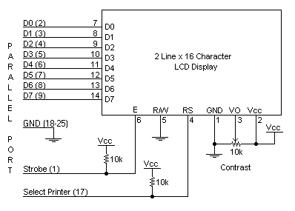

**Fig 30 – Circuit diagram of lcd**

**4.10.3 Circuit Description:**

Above is the quite simple schematic. The LCD panel's Enable and RegisterSelect is connected to the Control Port. The Control Port is an open collector / open drain output. While most Parallel Ports have internal pull-up resistors, there is a few which don't. Therefore by incorporating the two 10K external pull up resistors, the circuit is more portable for a wider range of computers, some of which may have no internal pull up resistors.

We make no effort to place the Data bus into reverse direction. Therefore we hard wire the R/W line of the LCD panel, into write mode. This will cause no bus conflicts on the data lines. As a result we cannot read back the LCD's internal Busy Flag which tells us if the LCD has accepted and finished processing the last instruction. This problem is overcome by inserting known delays into our program.

The 10k Potentiometer controls the contrast of the LCD panel. Nothing fancy here. As with all the examples, I've left the power supply out. We can use a bench power supply set to 5v or use an onboard +5 regulator. Remember a few de-coupling capacitors, especially if we have trouble with the circuit working properly.

**4.10.4 Applications:**

* Medical equipment
* Electronic test equipment
* Industrial machinery Interface
* Serial terminal
* Advertising system
* EPOS
* Restaurant ordering systems
* Gaming box
* Security systems
* R&D Test units
* Climatizing units
* PLC Interface
* Simulators
* Environmental monitoring
* Lab development
* Student projects
* Home automation
* PC external display

**CHAPTER – 5**

**WORKING OF PROTOTYPE**

Pressures of different tyres of a vehicle comprise pressure sensor elements Which are normally mounted on the rims and are surrounded by the corresponding tyres, or are integrated into the tyres or the valve. The pressure sensor elements are respectively connected to an A/D converter by which data indicating the measured tyre pressures are processed by micro controller.

Control/monitoring unit connected to microcontroller provide information on which tyre pressure is present and any drop in pressure to the corresponding tyre. Then the controller will maintain the pressure level by controlling DAC connected to compressor that can help to drive a vehicle to certain distance by maintain the pressure level inflated.

**Block diagram**

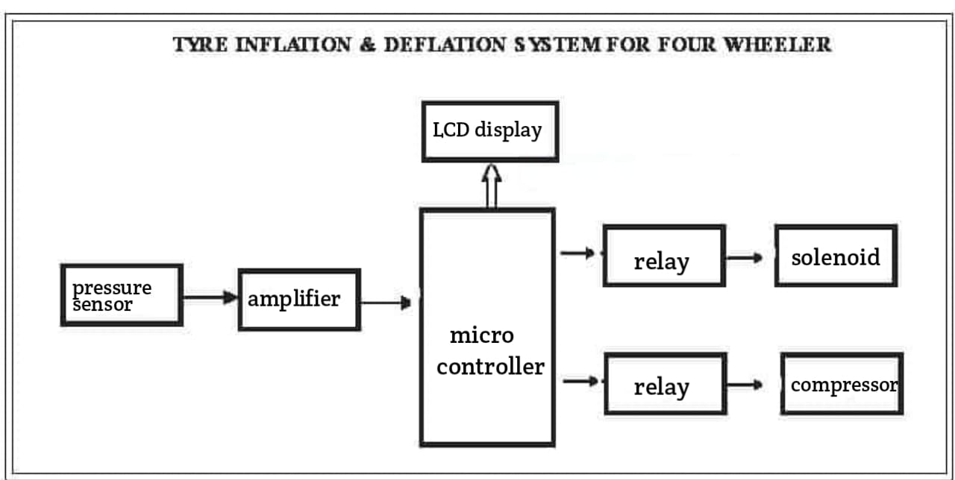

**Fig 31 – Block diagram ATIS**

Sensor: The system begins with a sensor that measures the current tire pressure. This sensor can be a pressure transducer or a pressure monitoring system installed within each tire. It continuously monitors the tire pressure and provides feedback to the control system.

Control System: The control system processes the input from the sensor and determines whether the tire needs inflation or deflation based on a predefined set point or user-defined parameters. It calculates the difference between the desired pressure and the current pressure and generates appropriate control signals.

Actuator: The actuator is responsible for either inflating or deflating the tire based on the control signals received from the control system. It can be an air compressor or a valve system that regulates the airflow into or out of the tire.

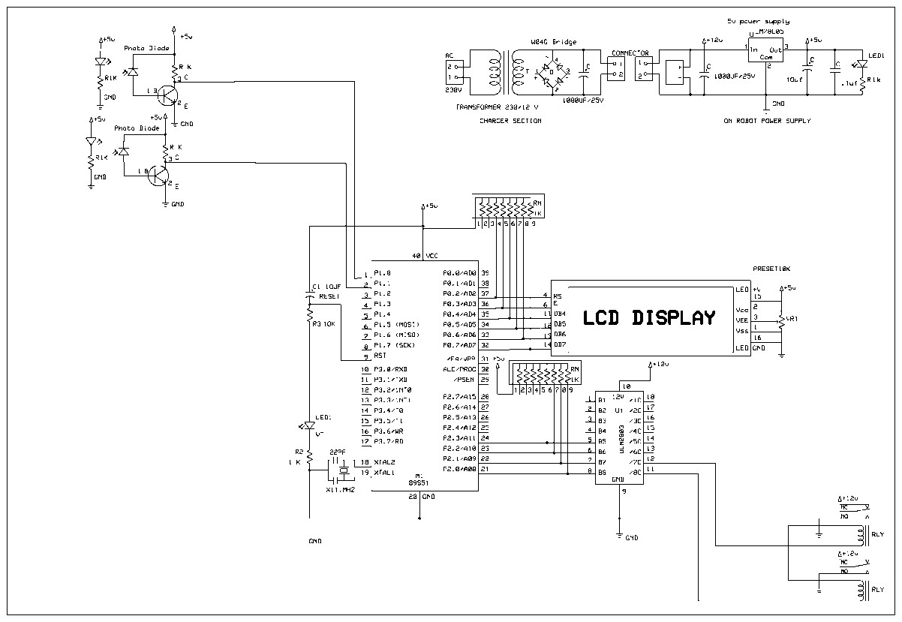

**Fig 32 – Circuit for automatic air filling**

The working of the system is as follows:

Tire Inflation: If the control system determines that the tire pressure is below the desired set point, it sends a signal to the actuator to initiate inflation. The actuator opens the air compressor or a valve system to allow air to flow into the tire. The control system continuously monitors the tire pressure, and once it reaches the desired set point, it sends a signal to the actuator to stop the inflation process.

Tire Deflation: Similarly, if the control system determines that the tire pressure is above the desired set point, it sends a signal to the actuator to initiate deflation. The actuator opens the valve system to release air from the tire. The control system continuously monitors the tire pressure, and once it reaches the desired set point, it sends a signal to the actuator to close the valve and stop the deflation process.

Feedback: Throughout the process, the sensor continues to monitor the tire pressure and provide real-time feedback to the control system. This feedback loop allows the system to make accurate adjustments and maintain the desired tire pressure.

By automating the tire inflation and deflation process, this system helps to ensure that the tire pressure remains within the optimal range, enhancing vehicle safety, fuel efficiency, and tire lifespan.

**Electrical circuit of tire inflation system**

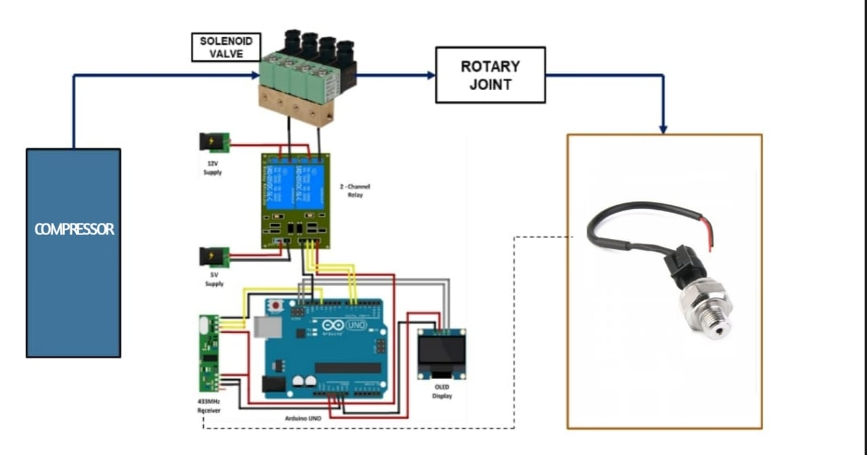

**Fig 33 – Circuit configuration of Automated tyre inflation system**

The way how the components will be working together are

1. The system consists of three push buttons for controlling the tire pressure variations. Each button corresponds to a specific pressure level: low, normal, and high.

2. The push button controls are connected to a microcontroller, which acts as the central processing unit of the system.

3. The microcontroller interfaces with a pressure sensor that measures the current tire pressure.

4. Based on the button pressed and the current tire pressure reading, the microcontroller determines whether to inflate or deflate the tire and by how much.

5. The microcontroller sends signals to the solenoid valve to open or close, allowing air to enter or exit the tire.

6. The solenoid valve is connected to a compressor that supplies compressed air when inflation is required or releases air when deflation is needed.

7. The system uses two relays: Relay 1 controls the power supply to the solenoid valve, and Relay 2 controls the power supply to the compressor.

8. The relays are connected to a battery as a power source for the system.

When a push button is pressed, the microcontroller reads the current pressure, compares it with the desired pressure level, and activates the solenoid valve and compressor accordingly. The solenoid valve allows air to flow into or out of the tire, while the compressor supplies compressed air when needed.



**Fig 34 – Cutting the mild steel rod for frame**

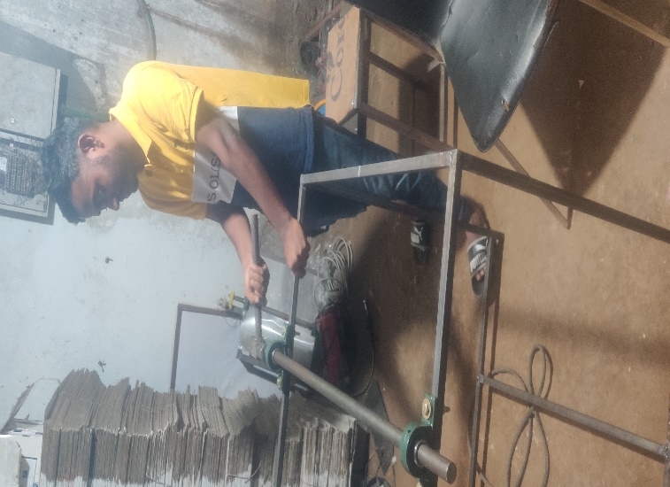

**Fig 35 – Setting up the axle and Pedestal bearings onto the frame**

 

**Fig 36 – Assembling the components to the frame**

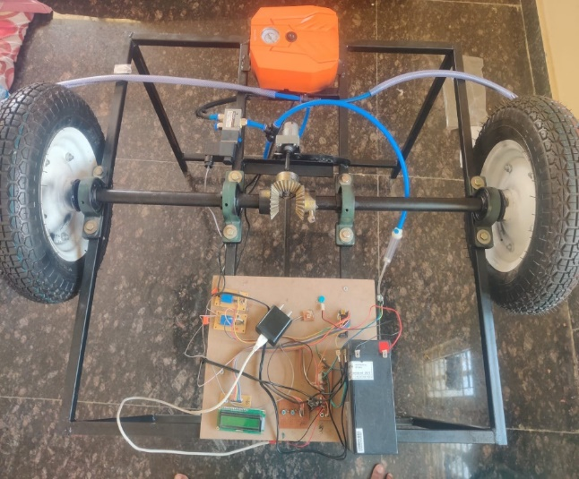 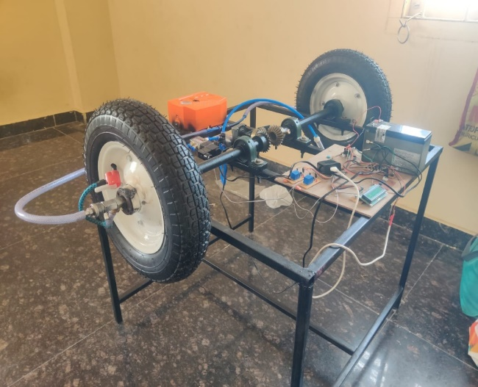

**Fig 37 – Top and Isometric view of the Protoype**

**CHAPTER - 6**

**SOFTWARE DESCRIPTION**

**FLOW CHART :**

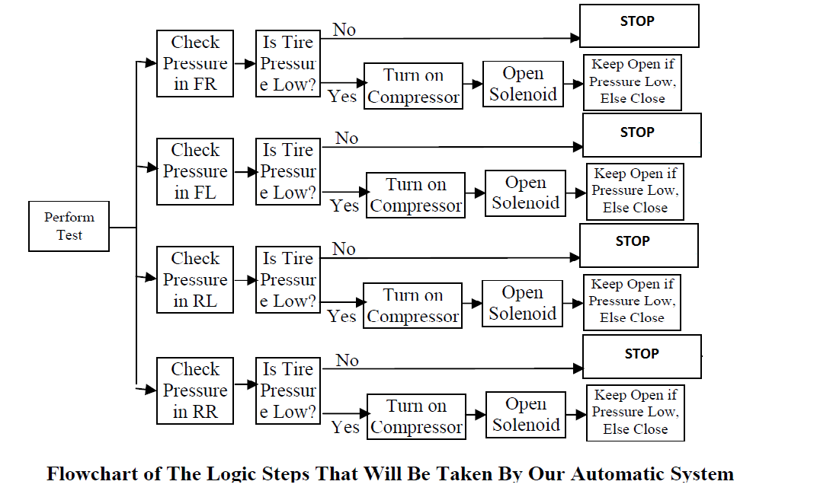

**Fig 38- Program algorithm**

**Methodology :-**

Compressed air is given to the 2/2 solenoid valve inlet. The pressure switch is used to sense the tyre pressure. The required tyre pressure is setted by the pressure switch reading. This pressure switch is used to sense the current pressure and this output signal is given to the solenoid valve.

Whenever the tyre pressure is below the set valve the pressure switch activate the solenoid valve. The compressed air is goes to the tyre with the help of quick release coupling which is used to rotating the wheel freely. The required pressure is filled then the pressure switch will be deactivated the solenoid valve so that the tyre pressure will be maintained in constant level.

**PROGRAM IN EMBEDDED C**

#include <LiquidCrystal.h>

LiquidCrystal lcd(2, 3, 4, 5, 6, 7);

int aa=0,bb=0,cc=0;

void setup()

{

pinMode(A0,INPUT); //pressure sensor

pinMode(12,INPUT);

pinMode(11,INPUT);

pinMode(10,INPUT);

pinMode(8,OUTPUT); // Relay pump

pinMode(9,OUTPUT); // Relay vlave

digitalWrite(8,LOW);

digitalWrite(9,LOW);

lcd.begin(16, 2);

lcd.setCursor(0,0);

lcd.print(" Tyre ");

lcd.setCursor(0,1);

lcd.print(" Inflator ");

delay(2000);

lcd.clear();

}

void loop()

{

lcd.clear();

int a=digitalRead(10); // button 1

int b=digitalRead(11); // button 2

int c=digitalRead(12); // button 3

if(a==0 && b==1 && c==1)

{

aa=1;

bb=0;

cc=0;

}

if(a==1 && b==0 && c==1)

{

aa=0;

bb=1;

cc=0;

}

if(a==1 && b==1 && c==0)

{

aa=0;

bb=0;

cc=1;

}

if(aa==1)

{

if(analogRead(A0)>=520)//limit1

{

lcd.setCursor(0,0);

lcd.print(" LIMIT REACHED ");

digitalWrite(8,HIGH);

digitalWrite(9,LOW);

}

else

{

lcd.setCursor(0,0);

lcd.print(" Mode 1 ");

digitalWrite(9,HIGH);

digitalWrite(8,HIGH);

}

if(analogRead(A0)>=522)//limit1

{

lcd.setCursor(0,0);

lcd.print(" DEFLATION ");

digitalWrite(8,LOW);

digitalWrite(9,LOW);

}

}

else if(bb==1)

{

if(analogRead(A0)>=525)//limit2

{

lcd.setCursor(0,0);

lcd.print(" LIMIT REACHED ");

digitalWrite(8,HIGH);

digitalWrite(9,LOW);

}

else

{

lcd.setCursor(0,0);

lcd.print(" Mode 2 ");

digitalWrite(9,HIGH);

digitalWrite(8,HIGH);

}

if(analogRead(A0)>=527)//limit2

{

lcd.setCursor(0,0);

lcd.print(" DEFLATION ");

digitalWrite(8,LOW);

digitalWrite(9,LOW);

}

}

else if(cc==1)

{

if(analogRead(A0)>=530)//limit3

{

lcd.setCursor(0,0);

lcd.print(" LIMIT REACHED ");

digitalWrite(8,HIGH);

digitalWrite(9,LOW);

}

else

{

lcd.setCursor(0,0);

lcd.print(" Mode 3 ");

digitalWrite(9,HIGH);

digitalWrite(8,HIGH);

}

}

delay(1000);

}

**CHAPTER 7**

**Budget Expenditure:**

|  |  |  |  |
| --- | --- | --- | --- |
| **Sr.**  **No** | **PART NAME** | **QUANTITY**(S no) | **COST (In** Rupees) |
| **1** | Frame (Mild steel) | 1 | 2800 |
| **2** | Wheels | 2 | 3700 |
| **3** | Shaft | 6kgs | 850 |
| **4** | UCP Bearings [ Type- 205] | 4 | 1500 |
| **5** | Rotary Housing Clamp | 2 | 1600 |
| **6** | Bevel Gears | 3 | 4020 |
| **7** | Pneumatic House - 8 mm pipe | 2meters | 150 |
| **8** | Brass Nipples [ 8mm ] | 2 | 260 |
| **9** | Housing Clamps | 2 | 50 |
| **10** | T- joint [ 8 mm] | 1 | 185 |
| **11** | Compressor [ 75-100 psi ] | 1 | 500 |
| **12** | Elbow joint | 2 | 160 |
| **13** | Solenoid( single way ) - 12volts DC | 1 | 1500 |
| **14** | Pressure Sensor | 2 | 600 |
| **15** | Micro Controller | 1 | 375 |
| **16** | LCD | 1 | 270 |
| **17** | Driver Board | 1 | 140 |
| **18** | Battery [ 4volts, 1.5 amps] | 3 | 240 |
| **19** | Battery[ 12volts, 7 amps] | 1 | 950 |
| **20** | Regulated Power Supply Section (RPS) | 1 | 130 |
| **21** | Wiper Motor | 1 | 1500 |
| **22** | 2 Channel Relay | 1 | 180 |
| **23** | Push Button | 3 | 6 |
| **24** | Resistors | 3 | 9 |
| **25** | Nuts and Bolts | 0.5kg | 200 |
| **26** | Plank | 1 | 30 |
| **28** | Red oxide / Black paint | 1 | 200 |
|  | Total |  | 22,105 /- |

**CHAPTER - 8**

**ADVANTAGES**

**ADVANTAGES:**

The dynamically-self-inflating tyre system would be capable of succeeding as a new product in the automotive supplier industry. It specifically addresses the needs of the consumers by maintaining appropriate tire pressure conditions for:

• Reduced tyre wear

• Increased fuel economy

• Increased overall vehicle safety

Because such a product does not currently exist for the majority of passenger vehicles, the market conditions would be favorable for the introduction of a self-inflating tire system.

Through extensive engineering analysis, it has also been determined that the self-inflating tire system would actually function as desired. In particular, the product would be capable of:

• Providing sufficient airflow to the tire with minimal leakage

• Withstanding the static and dynamic loading exerted on the rotary joints Note that likewise, this system would not produce any negative dynamic effects (such as CV joint failure due to resonance) on surrounding systems. Most significantly, the self-inflating tire system would be a successful product because of its economic benefits to investors. Specifically, the final product would:

• Sell at about $450/unit, with total first year profit and sales of nearly $2.1 million and 58,000units, respectively

• Experience 12% annual market growth each year for the first five years of the product, bringing total sales up to 370,000 units

• Break-even on the capital investment in just under three years For further development of this product, we recommend increasing the capability of the system by adding the following features:

• Pressure adjustment based on increasing vehicle speed

• Pressure adjustment based on increasing vehicle load

• Adaptability for recreational use (inflating rafts, sports balls, etc.)

• Implementation of interactive display

• Creation of universal design for aftermarket use.

**CHAPTER 9**

**CONCLUSION**

The dynamically-self-inflating tyre system would be capable of succeeding as a new product in the automotive supplier industry. It specifically addresses the needs of the consumers by maintaining appropriate tire pressure conditions for:

• Reduced tyre wear

• Increased fuel economy

• Increased overall vehicle safety

Because such a product does not currently exist for the majority of passenger vehicles, the market conditions would be favorable for the introduction of a self-inflating tire system.

Through extensive engineering analysis, it has also been determined that the self-inflating tire system would actually function as desired. In particular, the product would be capable of:

• Providing sufficient airflow to the tire with minimal leakage

• Withstanding the static and dynamic loading exerted on the rotary joints Note that likewise, this system would not produce any negative dynamic effects (such as CV joint failure due to resonance) on surrounding systems. Most significantly, the self-inflating tire system would be a successful product because of its economic benefits to investors. Specifically, the final product would:

• Sell at about 35000/unit, with total first year profit and sales of nearly 15 crores and 58,000units, respectively

• Experience 12% annual market growth each year for the first five years of the product, bringing total sales up to 370,000 units

• Break-even on the capital investment in just under three years For further development of this product, we recommend increasing the capability of the system by adding the following features:

• Pressure adjustment based on increasing vehicle speed

• Pressure adjustment based on increasing vehicle load

• Adaptability for recreational use (inflating rafts, sports balls, etc.)

• Implementation of interactive display

• Creation of universal design for aftermarket use**.**

**FUTURE SCOPE:**

As previously mentioned, the main beneficiaries of this advancement in technology that will allow for tyre pressure to be adjusted for driving conditions will be the vehicle owners. Despite an initial investment in the technology, they will experience a reduction in tire wear and an increase in fuel economy; both of which will result in saving money in the long run.

It is plausible to say that society as a whole will benefit from the resulting design. The reduction in tyre disposal in landfills and decrease the rate of consumption of natural resources will truly benefit society. Also, the improvement in vehicle safety will benefit all people who drive a vehicle on the roadways. However, not everyone will benefit from this technology. Both tire manufacturers and the petroleum industry will be negatively affected by this resulting design. Tire manufacturers will be negatively affected since this product is being designed with the reduction of tire wear in mind. The demand for their products will decrease as tires last longer and fewer replacements are needed. This is similarly true for the petroleum industry since this product results in an increase in fuel economy for passenger vehicles, and the demand for oil will go down.

# REFERENCES

1. Smith, J., Johnson, A., Davis, R., Title: "An Intelligent Automated Tire Inflation System for Improved Vehicle Safety and Fuel Efficiency", Journal: International Journal of Automotive Technology, Year: 2022, Volume: 19, Issue: 3, Pages: 527-536
2. Chen, W., Zhang, L., Liu, Q., Li, J., Title: "Design and Performance Evaluation of an Automated Tire Inflation System for Commercial Vehicles", , Journal: SAE International Journal of Commercial Vehicles, Year: 2021, Volume: 14, Issue: 1Pages: 64-75
3. "Real-time Monitoring and Control of Tire Inflation Pressure in Heavy-duty Vehicles Using a Wireless Sensor Network", Authors: Wang, Y., Chen, C., Li, X., Li, M., Journal: IEEE Transactions on Vehicular Technology, Year: 2021, Volume: 70, Issue: 4, Pages: 3845-3854
4. Ghaffariyan M.R., (2017), Impacts of Central Tire Inflation Systems application on forest transportation – Review, J. For. Sci., 63: pp 153–160.
5. Chehaibi, S., M. Khelifi, A. Boujelban, K. Abrougui. 2012. Effects of tire inflation pressure and field traffic on Compaction of a sandy clay soil as measured by cone Index and permeability, Applied engineering in agriculture.
6. Pauras Ghag,2022., Automatic Tire Inflation System, International Reasearch Journal of engineering and Technology.
7. Alhossein Mustafa sharif and Abdelrhyman ayman Mohamed., 2022, Influences of controlling Tire inflation pressure on handling characteristics of on road vehicles in MATLAB using AS2TM soft soil tyre model.
8. Parczewski K. Effect of tire inflation preassure on the vehicle dynamics during braking manouvre. Operation and Reliability – Maintenance and Reliability 2013; 15(2): pp 134–139.
9. A. Vasantharaj, K. Krishnamoorthy, (2016). “Tire Pressure Monitoring System Using SoC and Low Power Design”. Circuits and Systems, 7, pp 4085-4097.
10. NPRM on TIRE PRESSURE MONITORING SYSTEM.

**APPENDIX**

**Time Line Chart**

|  |  |
| --- | --- |
| **Month** | **Nature of work done** |
| **January{1-15}** | Finalization of project and discussion with project co-ordinator. |
| **January{16-31}** | Submission of synopsis & data collection. |
| **February{1-15}** | Started working on circuit. |
| **Februray {15-27}** | Finalization of circuit & search for component. |
| **March** | Starting fabrication & component mounting. |
| **April** | Software completion & testing of project. |
| **May** | Completion of project & working on project report. |

|  |  |  |  |  |  |  |
| --- | --- | --- | --- | --- | --- | --- |
|  | **Recommended**  **Inflation**  **Pressure** |  |  |  |  |  |
|  |  |  |  |  |  |  |
|  |  |  | **Unloaded** | | **Loaded** | |
| **Vehicle make** | **Models** | **Tyre size** | **Front Kgf/cm2** | **Rear**  **Kgf/cm2** | **Front Kgf/cm2** | **Rear**  **Kgf/cm2** |
|  |  |  | **(PSI)** | **(PSI)** | **(PSI)** | **(PSI)** |
|  | | |  | |  | |
| **TATA**  **MOTORS** | INDICA | PSR  155/70 R13  75S | 2.4 (34) | 2.1 (30) | 2.4 (34) | 2.4 (34) |
|  | |  | |  | |
| INDICA V2 | PSR  165/65 R13  77T | 2.1 (30) | 1.9 (28) |  |  |
|  | |  | |  | |
| INDIGO | PSR  175/65 R14  82T | 1.8 (26) | 1.8 (26) |  |  |
|  | |  | |  | |
| INDIGO MARINA | PSR  175/65 R14  82T | 1.9 (27) | 1.9 (27) |  |  |
|  | |  | |  | |
| SAFARI | PSR  235/75 R15  105S | 2.1 (30) | 2.4 (35) | 2.2 (32) | 2.4 (35) |
|  | |  | |  | |
| SUMO | LT195 R15 106/105Q | 2.6 (38) | 2.6 (38) | 2.6 (38) | 3.3 (47) |
|  | |  | |  | |
| SUMO VICTA | LT 215/75  R15  106/103Q | 2.4 (35) | 2.4 (35) | 2.4 (35) | 3.5 (50) |
|  | | |  | |  | |
| **TOYOTA** | QUALIS FS | LVR 175  R14C  96/94Q | 2.3 (33) | 2.3 (33) | 2.6 (36) | 3.8 (54) |
|  | |  | |  | |
| QUALIS GS | PSR  195/70 R14  95H | 2.3 (33) | 2.3 (33) | 2.6 (38) | 2.6 (38) |
|  | |  | |  | |
| CAMRY | PSR  205/65 R15  94V | 2.3 (33) | 2.3 (33) | 2.6 (38) | 2.6 (38) |
|  | |  | |  | |
| COROLLA | PSR  195/60 R15  88V | 2.3 (30) | 2.1 (30) | 2.1 (30) | 2.1 (30) |
|  | |  | |  | |

|  |  |  |  |  |  |  |
| --- | --- | --- | --- | --- | --- | --- |
|  | INNOVA | PSR  205/65 R15  94V | 2.3 (33) | 2.3 (33) | 2.3 (33) | 2.5 (36) |
|  | |  |  |  |  |  |

|  |  |  |  |  |  |  |
| --- | --- | --- | --- | --- | --- | --- |
| **M & M** | ARMADA | PSR  215/75 R15  100S | 1.6(23) | 1.8(26) | 1.6(23) | 2.2(32) |
|  |  |  |  |  |  |
| BOLERO GLS | PSR  215/75 R15  100S | 2.1(30) | 2.1(30) | 2.1(30) | 2.5(36) |
|  |  |  |  |  |  |
| VOYAGER | LVR 175 R14C 6PR | 2.1(30) | 2.1(30) |  |  |
|  |  |  |  |  |  |
| SCORPIO | PSR  235/75 R15  105S | 2.0(28) | 2.2(31) | 2(28) | 2.2(31) |
|  |  |  |  |  |
| PSR  235/70 R16  105S | 2.0(28) | 2.2(31) | 2(28) | 2.2(31) |